User Scenario
Permaculture Visons Jamie McMillin
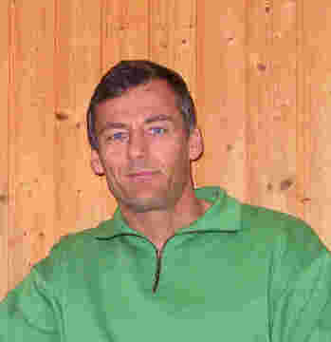
NAME: Bruce
AGE: 40
GENDER: Male
LOCATION: Wrangell Island and Juneau Alaska
EDUCATION: BS Mechanical Engineering, MA Theology
FAMILY: Married, one child
HOBBIES: Boating, gardening, reading
OCCUPATION: Coast Guard reservist, homesteader
INCOME: Active Duty, O-6
WORK HOURS: Works for Coast Guard in Juneau during winter months
(Oct – Mar) for 8-9 hours per day. During the rest of the
year, he lives on his remote homestead on Wrangell Isl.
DISABILITIES: None
COMPUTER: Mac lap-top (3 years old), PC at work
MONITOR: 1024 X 768
NETWORK: Satellite in Wrangell, dial up AOL in Juneau
TECH SKILL: Competent user, computer is tool, not hobby

USER GOAL:
- Find more info on permaculture for personal use

SITE INTERACTION EPISODE

- Bruce is interested in maximizing the food production and sustainability of his remote homestead in Wrangell. He has heard about “permaculture” in one of his gardening books, so he opens Google and types in <permaculture>.
- He finds a number of general sites that describe permaculture and usually offer courses at various locations. He does a more specific Google search for <permaculture Alaska>. He does not find any permaculture courses in Alaska, but sees the web site for Permaculture Visions second on the list because Alaska is one of its keywords.
- He clicks on the permaculturevisions.com link and views the home page. He does not see the links inside the flower petals and clicks on the first bold link, which is “Introduction to Permaculture.”
- The page opens and Bruce sees that this is a lot of general info which he has already seen in other sites. He does not bother scrolling down but hits the back button. Back at the home page he scrolls down farther and finds the section on “Courses.” He clicks on the first link, which is “Introductory Course.”
- The Introductory Course page opens, and he scans quickly through it. He sees another link for the “Design Course” and clicks it. This page has a table which is quick and easy to read. He reads the whole page and scrolls to the bottom, where he finds a link for “Fees and How to Enrol.”
- He checks the fee table for the cost in US dollars. He isn’t scared off by the price but needs to know more about the course, so he hits the back button. He sees another link on the bottom of the page for “Our Student Profile.” He checks this, scanning the information to the bottom, then sees a new link for “Show a Permaculture Design.”
- This page is just a simple drawing with no explanation so he hits the back button. The last link is “Traineeship Details.” He quickly scans this information and finds the link back to the main page. On the main page he sees where he left at the “Introductory Course” and below that a link for “PDC – Permaculture Design Course.” He wonders if this is the same page he already looked at and clicks on the link. He finds that it is the same and hits back. He wonders if he can learn more about permaculture without paying for a course. He wants to find out what materials the course uses. He looks around on the home page for a link to books or curriculum but cannot find anything.
- He leaves and heads to amazon.com

User Scenario
Permaculture Visons

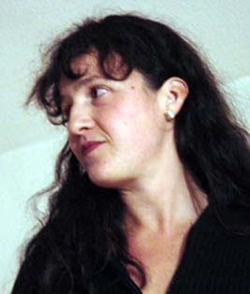

NAME: Theresa
AGE: 38
GENDER: Female
LOCATION: Northern Connecticut
EDUCATION: BA Business
FAMILY: Married, four children
HOBBIES: Gardening, baseball, volunteering/food co-op
OCCUPATION: Home schools children, wants to open farm-stand
INCOME: Husband’s average income is $65,000 per year
WORK HOURS: 16 hours a day every day
DISABILITIES: None
COMPUTER: PC (5 years old)
MONITOR: 1024 X 768
NETWORK: dial up AOL
TECH SKILL: basic home/internet use

USER GOAL:
- Find more info on permaculture for personal use

SITE INTERACTION EPISODE

- Theresa is interested in opening a farm-stand to sell her excess organic produce. She envisions building a bigger, better, more sustainable garden, which could completely feed her vegetarian family plus add a little to the family income. She has read about permaculture in her organic gardening magazine and wonders if taking a course would help her.

- She uses the AOL search engine to research permaculture internet courses. She knows she cannot take a course in person because she cannot leave her kids for any length of time. She does a search for <online permaculture course> and tries a number of sites, which do not seem legitimate or serious enough. She finally finds “Permaculture Visions.”

- On the “Permaculture Visions” web site, she does not see the links inside the petals and scrolls down the home page instead. She clicks on the first link “Introduction to Permaculture” and reads the page. This is informative for her and she hits the back button. On the home page, she methodically clicks on each successive link, reading each page until she gets to the “Tools” chart on the bottom.

- She clicks on the link “Women in Permaculture,” then the three pages for children. She then read the page on “Getting Started in Permaculture.” She is getting excited because this seems like exactly what she wants to do. She returns to the home page and scrolls down to read about the creators of the site and then sees the links to other sites.

- She checks out the other links but these seem to be more about international and environmental issues. She wants more concrete information to use in her own garden. She returns to the course information page to study the fees and scope of instruction. She prints out information to share with her husband later.
User Scenario
Permaculture Visons
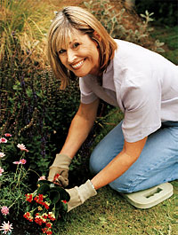

NAME: Barbara
AGE: 58
GENDER: Female
LOCATION: Oregon
EDUCATION: BA and MA Education
FAMILY: Married, two grown children
HOBBIES: Gardening, writing, volunteering, genealogy, reading
OCCUPATION: Retired teacher
INCOME: Comfortable retiree income with husband
WORK HOURS: None
DISABILITIES: Needs reading glasses
COMPUTER: New Mac
MONITOR: 1024 X 768
NETWORK: dial up Earthlink
TECH SKILL: basic home/internet use

USER GOAL:
- Find online courses on permaculture

SITE INTERACTION EPISODE

- Barbara was interested in learning about permaculture so she used the “Yahoo” search engine to find sites about it. The first site she found was for “Permaculture Research Institute.” She read the home page and found a link for “Courses.” All the courses listed were in other countries. She wondered if there were any online courses.
- She went back to Yahoo and typed in <permaculture online courses>. There were various other sites, which did not look very substantial. She clicked on “Permaculture Visions.”
- On the home page, she thought the flower graphic was corny, but saw the links inside the petals and clicked on “Courses.” She clicked on “Introductory Course.” She read this and wondered “Is this online?” She went back to the home page and saw “Permaculture Online Courses” written across the front. This answered her question. She then clicked on the “Courses” petal again and then to “PDC – Design Course.”
- She read this page and felt that there was too much text on a boring background. She wanted more pictures and went back to the previous page. She clicked on “Our Student Profile” and started to lose interest. The poor layout of the web site did not give her confidence that this organization would be worth taking a course from.
- She went back to the home page and scrolled down to the “Tools” table. She thought this was more interesting and clicked on “Herb Spiral.” She read this and said “Now this is good information – but they need a picture!” She then wondered what the intent of the site was – to interest people in their courses or provide information?
- She read the “About” link next to the photo of the couple and briefly read their background information. She was amazed to see that their land was only 1 acre.
- Barbara decided that this site was not interesting enough and left.

