2014 KapCC CCSSE Benchmark Report Summary

09/18/2014

Table of Contents
Executive Summary 1
CCSSE Benchmark Introduction................................................................................................................2-4

When to use Weights.....................................................................................................................................4

2014 KapCC Benchmark Scores....................................................................................................................5

KapCC Benchmark Comparisons with Large Colleges in the 2014 Cohort..................................................6

KapCC Benchmark Comparisons with University of Hawaii Community Colleges......................6
KapCC Benchmark Comparisons with Top-Performing Colleges..................................................7
KapCC Benchmark Comparisons with Achieving the Dream Colleges 7
KapCC Deciles Report.....................................................................................................................8
KapCC Breakout Report by First-Generation Status.......................................................................9
KapCC Breakout Report by Sex 9
KapCC Breakout Report by Developmental Status 10
KapCC Breakout Report by Enrollment Status.............................................................................10
KapCC Breakout Report by Credits Hours Earned.......................................................................11
KapCC and Native Hawaiian Benchmark Scores Comparison ...................................................11

Executive Summary

This summary is aimed to help administrators, faculty, and staff better understand the 2014 CCSSE official benchmark data released in late August. It starts with the introduction of CCSSE benchmark, and is followed by the comparisons of KapCC benchmark scores with larger colleges, Hawaii community colleges, top-performing colleges and ATD cohort in the 2014 cohort. It then presents KapCC deciles report. Lastly, it provides six additional KapCC breakout reports, including breakout reports by First-Generation Status, by developmental status, by enrollment status, and by credit hours earned. The benchmark scores of native Hawaiian students are also compared with KapCC cohort.

CCSSE Benchmark Introduction

To assist colleges in their efforts to reach for excellence, CCSSE introduced national benchmarks. Research shows that the more actively engaged students are — with college faculty and staff, with other students, and with the subject matter — the more likely they are to learn and to achieve their academic goals. The five benchmarks of effective educational practice in community colleges are: active and collaborative learning, student effort, academic challenges, student-faculty interaction, and support for learners.

Active and Collaborative Learning ( 7 items: 4a, 4b, 4f, 4g, 4h, 4i, and 4r)

Students learn more when they are actively involved in their education and have opportunities to think about and apply what they are learning in different settings. Through collaborating with others to solve problems or master challenging content, students develop valuable skills that prepare them to deal with the kinds of situations and problems they will encounter in the workplace, the community, and their personal lives. The following seven survey items contribute to this benchmark:
During the current school year, how often have you:
- Asked questions in class or contributed to class discussions (4a)
- Made a class presentation (4b)
- Worked with other students on projects during class (4f)
- Worked with classmates outside of class to prepare class assignments (4g)
- Tutored or taught other students (paid or voluntary) (4h)
- Participated in a community-based project as a part of a regular course (4i)
- Discussed ideas from your readings or classes with others outside of class (students, family members, co-workers, etc.) (4r)
Student Effort (8 items: 4c, 4d, 4e, 6b, 10a, 13d1, 13e1, and 13h1)
Students’ behaviors contribute significantly to their learning and the likelihood that they will attain their educational goals. “Time on task” is a key variable, and there are a variety of settings and means through which students may apply themselves to the learning process. Eight survey items that indicate how frequently students engage in a number of activities important to their learning and success are associated with this benchmark:
During the current school year, how often have you:
- Prepared two or more drafts of a paper or assignment before turning it in (4c)
- Worked on a paper or project that required integrating ideas or information from various sources (4d)
- Come to class without completing readings or assignments (4e)
- Used peer or other tutoring services (13d1)
- Used skill labs (13e1)
- Used a computer lab (13h1)
During the current school year:
- How many books did you read on your own (not assigned) for personal enjoyment or academic enrichment (6b)
- How many hours did you spend in a typical week preparing for class (studying, reading, writing, rehearsing, or other activities related to your program) (10a)
Academic Challenges (10 items: 4p, 5b, 5c, 5d, 5e, 5f, 6a, 6c, 7, and 9a)
Challenging intellectual and creative work is central to student learning and collegiate quality. Ten survey items address the nature and amount of assigned academic work, the complexity of cognitive tasks presented to students, and the standards faculty members use to evaluate student performance:
During the current school year, how often have you:
- Worked harder than you thought you could to meet an instructor’s standards or expectations (4p)
How much does your coursework at this college emphasize:
- Analyzing the basic elements of an idea, experience, or theory (5b)
- Synthesizing and organizing ideas, information, or experiences in new ways (5c)
- Making judgments about the value or soundness of information, arguments, or methods (5d)
- Applying theories or concepts to practical problems or in new situations (5e)
- Using information you have read or heard to perform a new skill (5f)
During the current school year:
- How many assigned textbooks, manuals, books, or book-length packs of course readings did you read (6a)
- How many papers or reports of any length did you write (6c)
- To what extent have your examinations challenged you to do your best work (7)
How much does this college emphasize:
- Encouraging you to spend significant amounts of time studying (9a)
Student-Faculty Interaction (6 items: 4k, 4l, 4m, 4n, 4o, and 4q)

In general, the more interaction students have with their teachers, the more likely they are to learn effectively and persist toward achievement of their educational goals. Personal interaction with faculty members strengthens students’ connections to the college and helps them focus on their academic progress. Working with an instructor on a project or serving with faculty members on a college committee lets students see first-hand how experts identify and solve practical problems. Through such interactions, faculty members become role models, mentors, and guides for continuous, lifelong learning. The six items used in this benchmark are:
During the current school year, how often have you:
- Used e-mail to communicate with an instructor (4k)
- Discussed grades or assignments with an instructor (4l)
- Talked about career plans with an instructor or advisor (4m)
- Discussed ideas from your readings or classes with instructors outside of class (4n)
- Received prompt feedback (written or oral) from instructors on your performance (4o)
- Worked with instructors on activities other than coursework (4q)

Support for Learners (7 items: 9b, 9c, 9d, 9e, 9f, 13a1, and 13b1)
Students perform better and are more satisfied at colleges that are committed to their success and cultivate positive working and social relationships among different groups on campus. Community college students also benefit from services targeted to assist them with academic and career planning, academic skill development, and other areas that may affect learning and retention. The following seven survey items contribute to this benchmark:
How much does this college emphasize:
- Providing the support you need to help you succeed at this college (9b)
- Encouraging contact among students from different economic, social, and racial or ethnic backgrounds (9c)
- Helping you cope with your nonacademic responsibilities (work, family, etc.) (9d)
- Providing the support you need to thrive socially (9e)
- Providing the financial support you need to afford your education (9f)
During the current school year, how often have you:
- Used academic advising/planning services (13a1)
- Used career counseling services (13b1)
When to Use Weights

In the CCSSE sampling procedure, students are sampled at the classroom level. As a result, full-time students, who by definition are enrolled in more classes than less than full-time students, are more likely to be sampled. To adjust for this sampling bias, CCSSE results are weighted using the most recently available IPEDS data.

Because weights are based on enrollment status, analysis of CCSSE results in which less than full-time students are in one group and full-time students in another group should not employ weights. Further, when comparing subgroups broken out by enrollment status (e.g., less than full-time male with less than full-time female students), weights should not be used. And, when reporting simple demographics (e.g., the number of male and female students, number of respondents by race/ethnicity), weights should not be used.

When comparing all members of one subgroup with members of another subgroup (e.g., all developmental students with all non-developmental students in which both less than full-time and full-time students are included in the analysis), weights should be used.
Another example of when to consider not using weights is when the vast majority of students at the college are either full-time or less than full-time. As an example, if 92% of students are full-time, a college may want to look at the unweighted results for full-time students to guide many campus decisions.

2014 KapCC Benchmark Scores

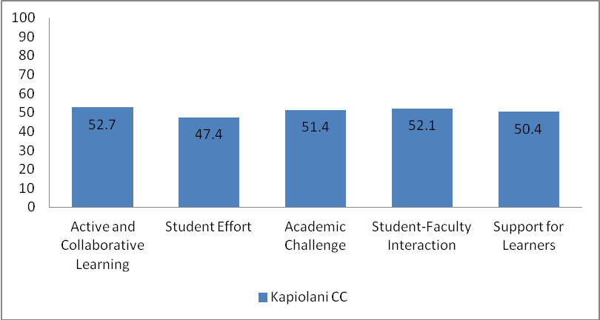
* Becnhmark scores are standardized around the mean of CCSSE Cohort respondents' scores so that benchmarks have a mean of 50, a standdard deviation of 25, and are weighted by full-time and less than full-time enrollment statuts. A standard deviation of 25 is used to ensure that over 95% of benchmark scores fall between zero and 100, providing an understandable scale for member colleges.

* Standardized benchmark scores are useful for comparing one college to a comparison group of colleges or the three-year cohort at any one point in time. Raw benchmark scores are the appropriate measures to use for college that wish to conduct longitudinal trend analyses.
*For the detailed information about how benchmark scores are calculated, please go to the OFIE website for Assessment & Evaluation.

2014 Benchmark Scores Comparison

Comparison Groups: Large Colleges in the 2014 Cohort

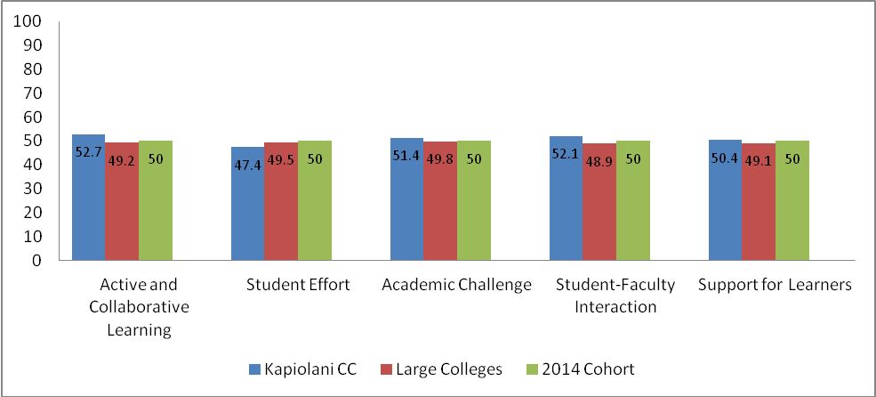

* According to CCSSE, small colleges (fewer than 4,499 students), medium colleges (4,500–7,999 students), large colleges (8,000–14,999 students), extra-large colleges (15,000 or more students)

*In addition to student effort, the benchmark scores for KCC are higher than large colleges in the 2014 cohort.

Comparison Group: University of Hawaii Community Colleges in the 2014 Cohort

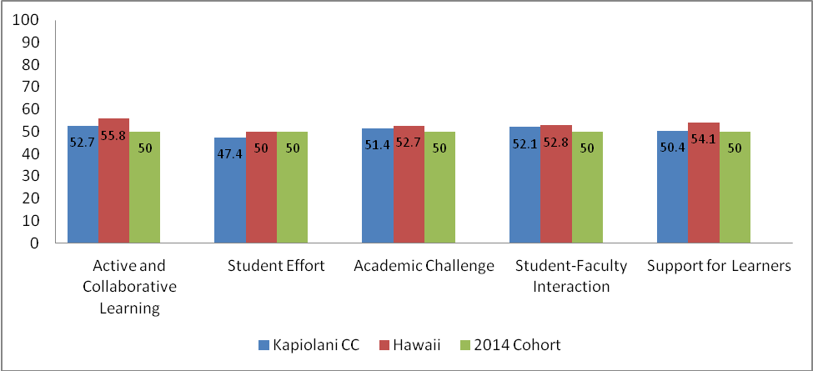

*Among the seven University of Hawaii Community Colleges, KCC is the only one that belongs to the category of large colleges.

Comparison Group: Top-Performing colleges in the 2014 Cohort

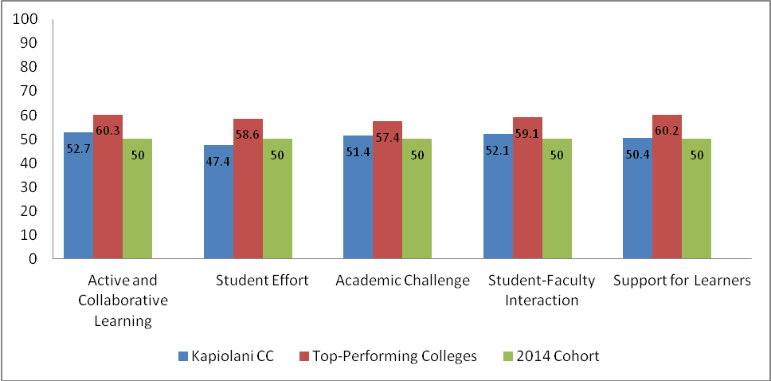

*Top-Performing colleges are those that scores in the top 10 percent of the cohort by benchmark.

Comparison Group: Achieving the Dream in the 2014 Cohort

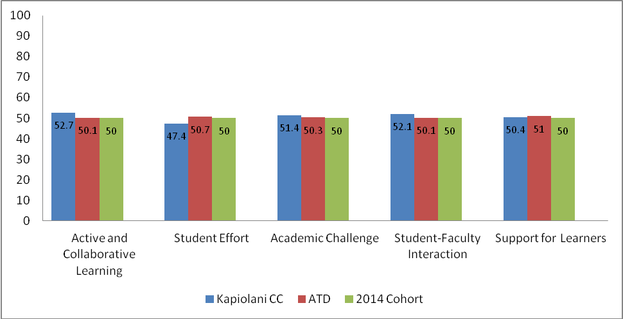

* KCC was part of the Achieving the Dream CCSSE 2014 consortium.

2014 KCC Deciles Report

 | Deciles
Benchmark | 0% | 10% | 20% | 30% | 40% | 50% | 60% | 70% | 80% | 90% | 100%
2014 Cohort
Active and Collaborative Learning | 39.6 | 45.3 | 46.8 | 47.8 | 48.8 | 49.7 | 50.6 | 51.9 | 53.2 | 56.2 | 84.6
Student Effort | 37.1 | 45.6 | 47.0 | 47.9 | 49.0 | 49.8 | 50.8 | 52.0 | 53.3 | 55.7 | 81.5
Academic Challenge | 38.6 | 45.8 | 47.3 | 48.3 | 49.0 | 49.8 | 50.6 | 51.6 | 52.6 | 54.9 | 69.0
Student-Faculty Interaction | 40.0 | 46.2 | 47.4 | 48.4 | 49.3 | 50.2 | 51.0 | 42.4 | 53.8 | 55.6 | 73.5
Support for Learners | 34.0 | 45.3 | 46.6 | 47.8 | 49.0 | 50.1 | 51.2 | 52.4 | 54.0 | 56.5 | 71.5
Large Colleges
Active and Collaborative Learning | 42.4 | 45.5 | 46.2 | 47.2 | 47.8 | 48.4 | 49.5 | 50.5 | 52.1 | 53.1 | 70.7
Student Effort | 40.9 | 46.1 | 46.9 | 47.5 | 48.0 | 49.2 | 49.7 | 51.0 | 52.4 | 53.4 | 60.8
Academic Challenge | 43.6 | 46.5 | 47.7 | 48.4 | 49.1 | 49.6 | 50.1 | 51.0 | 51.7 | 53.1 | 57.8
Student-Faculty Interaction | 40.0 | 44.5 | 46.3 | 47.3 | 47.9 | 48.7 | 49.6 | 50.6 | 51.7 | 52.9 | 57.6
Support for Learners | 40.9 | 45.1 | 46.1 | 47.2 | 48.0 | 49.0 | 50.0 | 51.0 | 51.8 | 53.2 | 61.4

* Deciles are percentile scores that divide the frequency of benchmark scores into ten equal groups. A percentile represents the point at or below which a specified percentage of the college benchmark scores fall. For example, the 60th percentile represents the point at or below which 60 percent of the college benchmark scores fall for the respective comparison group.

*Benchmark scores highlighted in blue represent KCC's benchmark percentile scores. In addition to student effort, the percentile scores for the other four benchmarks fall at or below 50 percent of the college benchmark scores for both 2014 cohort and large college groups. The 20th percentile represents the point at or below which 20 percent of the college benchmark scores fall for both comparison groups.

2014 CCSSE Benchmark KCC Student Level Breakout Reports
KCC Breakout by First-Generation Status

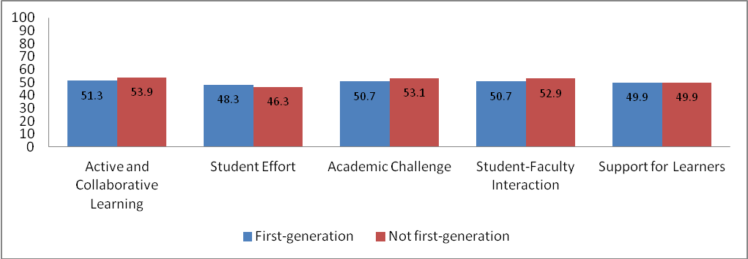

 | First-Generation | Not first-generation | Score Difference
Active and Collaborative Learning | 51.3 | 53.9 | -2.6
Student Effort | 48.3 | 46.3 | 2
Academic Challenge | 50.7 | 53.1 | -2.4
Student-Faculty Interaction | 50.7 | 52.9 | -2.2
Support for Learner | 49.9 | 49.9 | 0

KCC Breakout by Sex

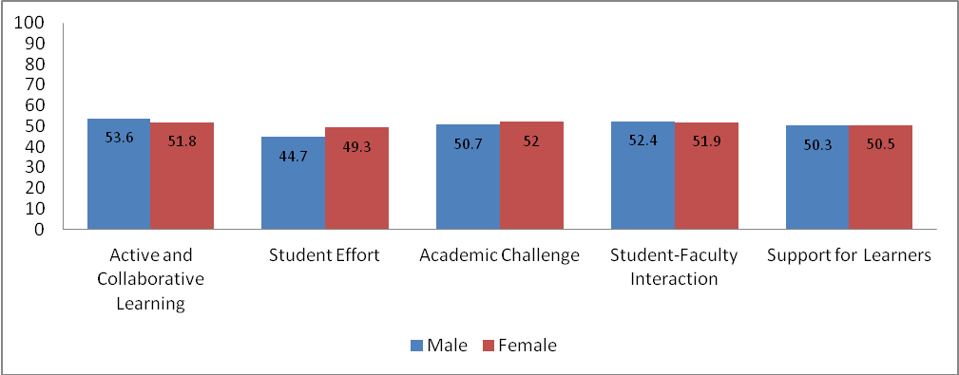

 | Male | Female | Score Difference
Active and Collaborative Learning | 53.6 | 51.8 | 1.8
Student Effort | 44.7 | 49.3 | -4.6
Academic Challenge | 50.7 | 52 | -1.3
Student-Faculty Interaction | 52.4 | 51.9 | 0.5
Support for Learner | 50.3 | 50.5 | -0.2

KCC Breakout by Developmental Status

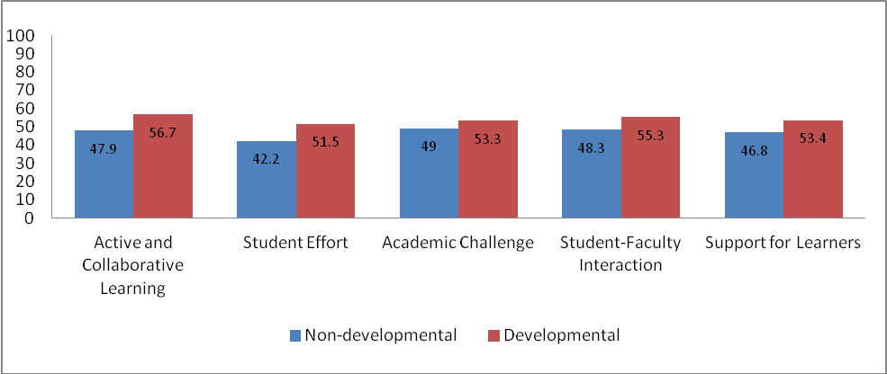

 | Non-developmental | Developmental | Score Difference
Active and Collaborative Learning | 47.9 | 56.7 | -8.8
Student Effort | 42.2 | 51.5 | -9.3
Academic Challenge | 49 | 53.3 | -4.3
Student-Faculty Interaction | 48.3 | 55.3 | -7
Support for Learner | 46.8 | 53.4 | -6.6

KCC Breakout by Enrollment Status

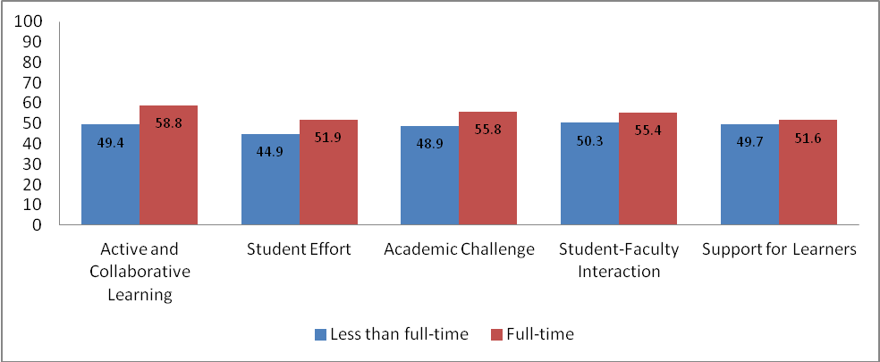

 | Less than full-time | Full-time | Score Difference
Active and Collaborative Learning | 49.4 | 58.8 | -9.4
Student Effort | 44.9 | 51.9 | -7
Academic Challenge | 48.9 | 55.8 | -6.9
Student-Faculty Interaction | 50.3 | 55.4 | -5.1
Support for Learner | 49.7 | 51.6 | -1.9

KCC Breakout by Credit Hours Earned

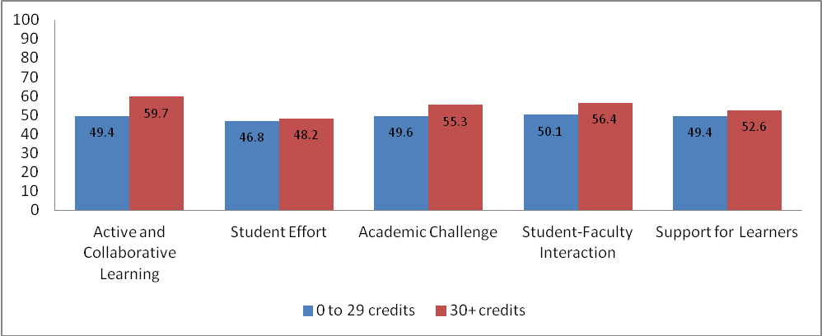

 | 0-29 credits | 30+ credits | Score Difference
Active and Collaborative Learning | 49.4 | 59.7 | -10.3
Student Effort | 46.8 | 48.2 | -1.4
Academic Challenge | 49.6 | 55.3 | -5.7
Student-Faculty Interaction | 50.1 | 56.4 | -6.3
Support for Learner | 49.4 | 52.6 | -3.2

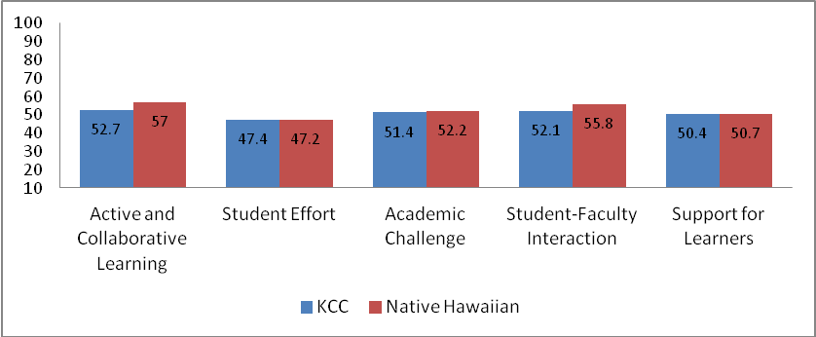

 | Native Hawaiian | KapCC | Score Difference
Active and Collaborative Learning | 57 | 52.7 | 4.3
Student Effort | 47.2 | 47.4 | -0.2
Academic Challenge | 52.2 | 51.4 | 0.8
Student-Faculty Interaction | 55.8 | 52.1 | 3.7
Support for Learner | 50.7 | 50.4 | -0.3

Contact Information:
Qiong Jia, Ph.D.
Institutional Analyst
Phone: (808)734-9763
ofie@hawaii.edu

