**IM LeeSports League General Information**

**The website to check for updates and complete forms is here (only accessible to Advisors and SL Staff):**

[**https://sites.google.com/a/hawaii.edu/im-leesports-league/**](https://sites.google.com/a/hawaii.edu/im-leesports-league/)

|  |  |  |  |  |  |  |  |
| --- | --- | --- | --- | --- | --- | --- | --- |
| **THE SPORT** | **DATES** | **TIMES** | **LOCATION** | **FEE PER**  **TEAM** | **TEAM REG Deadline** | **Team REG Extension Deadline. Submissions due by 4pm** | **IM LeeSports Logistics Meetings** |
| Basketball  5 vs 5  Min. 4  Max. 10 | February 2 – March 16 | Thursdays from 7:15pm-9:15pm | Aiea District Gym | $170 | Friday, January 20 at 11:59pm | Wednesday, January 25th | Week of January 16th or 23rd |
| Softball  11 v 11  Min. 9  Max. 22 | February 7-28 | Tuesdays from 6:30pm – 9:30pm | Moanalua Community Park | $170 | Monday, January 30th at 11:59pm | Wednesday, February 1st | Week of January 30th |
| Volleyball  6 vs 6  Min. 4  Max. 12 | April 5 – May 3 | Wednesdays from 5:45pm – 8:45pm | Pearl City District Gym | $170 | Friday, March 17 at 11:59pm | Wednesday, March 29th (due to spring break) | Week of March 13 or March 27th |

*NOTE: All sports are co-ed without a min. or max. number of players based on gender.*

**General Rules for all sports:**

* IM LeeSports refers to the U.S. Department of Justice and U.S. Department of Education: Dear Colleague Letter on Transgender Students regarding participation based on gender when it applies to co-ed specific rules that align with the gender identity to further advocate for an inclusive community. <http://www2.ed.gov/about/offices/list/ocr/letters/colleague-201605-title-ix-transgender.pdf>
* IM LeeSports staff is CPR and First Aid certified and will make the decision to keep a player off the court/field after an injury based on their judgement.
* To ensure the safety of all players the IM LeeSports Coordinator, Leeward Community College Student Life Coordinator, will require the following steps to be taken if a player is injured in order for them to play in future games:
  + The player will need to receive a signed clearance note from a health professional
  + The campus Advisor will need to email the Leeward CC Student Life Coordinator to indicate that they clear the player to play in future games

**OTHER FEES**

|  |  |  |
| --- | --- | --- |
| **WHAT FEES** | **FEE AMOUNT** | **WHEN WILL IT BE IMPLEMENTED** |
| **Forfeit Fee** | $15/game day/team | If any team forfeits during the league or tournament (after the first game is played or after 4pm the day before the first game) they will be charged the original league/tournament fee + $15 for every game forfeited.  The team can still play on that game day as a SCRIMMAGE.   * For leagues with multiple games in one evening: The $15 will only be applied once for the game day and not each game * For One Day Tournaments: The $15 will be applied for EACH game that is forfeited   Eligibility to advance to playoffs for one day tournaments with forfeited games will be determined at that time. |
| **Complete Team Forfeit Fee** | League/Tournament Fee | If any team forfeits by 4pm the DAY BEFORE the first game day then they will pay the league fee ONLY.  The $15 forfeit fee is not applied.  The team is then cut from the league. (Players cannot play in scrimmages.  IM LeeSports recommends that the players go on a "waitlist" for any other existing team on their campus)  It is encouraged to forfeit by the Friday before the first game day (not pre-season game).  Example: Football first game day is on September 27th.  Team forfeit by September 23rd. |
| **Team Registration Extension Fee** | $15/team. Fee is implemented if the team meets requirements by the extension deadline. | If a team is not formed or meets the player requirement by the registration deadline, however the campus wants to add a team then there will be an extension with an additional $15/team.  *(Please let IM LeeSports know that you want an extension by the Registration Deadline).* The extension team must meet the player requirement by extension deadline. |

**Team Registration and Player Addition Deadlines**

**To Register a TEAM for a sport:**

* Please check <https://sites.google.com/a/hawaii.edu/im-leesports-league/> for updated deadlines for each sport every semester.
* The team must have the MINIMUM number of players added to that team on the Players Information Form by the registration deadline. If the team does not meet the minimum number of players then the team will get cut, unless a team registration extension is requested.
* The Team Roster must be **EMAILED to** [**leeintramurals@gmail.com**](mailto:leeintramurals@gmail.com) **or to your campus IM LeeSports member** by the Team Registration deadline to submit for the team. Any changes to the team after the initial roster was submitted will just need to be emailed (see diagram below).  A roster does NOT need to be submitted for every game day.

|  |  |  |
| --- | --- | --- |
| **Team Registration Extension Fee** | $15/team. Fee is implemented if the team meets requirements by the extension deadline. | If a team is not formed or meets the player requirement by the registration deadline, however the campus wants to add a team then there will be an extension with an additional $15/team.  *(Please let IM LeeSports know that you want an extension by the Registration Deadline).* The extension team must meet the player requirement by extension deadline. |

**General registration period to ADD a player to an EXISTING Team for a sport:**

* Players can be added throughout the season.
* The deadline to add a player to your established team for a sport is **12pm on the game day**.

**Adding a player by 12pm on game day means:**

1. The Advisor/Student Life Office emails the changes to IM LeeSports before 12pm on game day
   1. The email subject line must read: **CHANGE REQUEST**
      1. Changes include but are not limited to:
         1. Adding a player if player requirement is not maxed out in this format:   
                       - First Name, Last Name

     - Student ID number

- Email address

- Phone Number

- Gender Identity

    - Under 18 years old?

- Emergency Contact Name

   - Emergency Contact Phone Number

    - Emergency Contact Relationship

* + - 1. Removing a player if player requirement is maxed out and then adding a player
      2. Editing inaccurate player information

*IM LeeSports Team will verify the change based on the time stamp on the email.*

A player may switch teams **IF THEY HAVE NOT PLAYED** with their existing team.  If the player already played a game with a team they cannot switch teams.

*In order for the player to be eligible to participate in playoffs they must have been on the game roster for at least one game (league sports).*

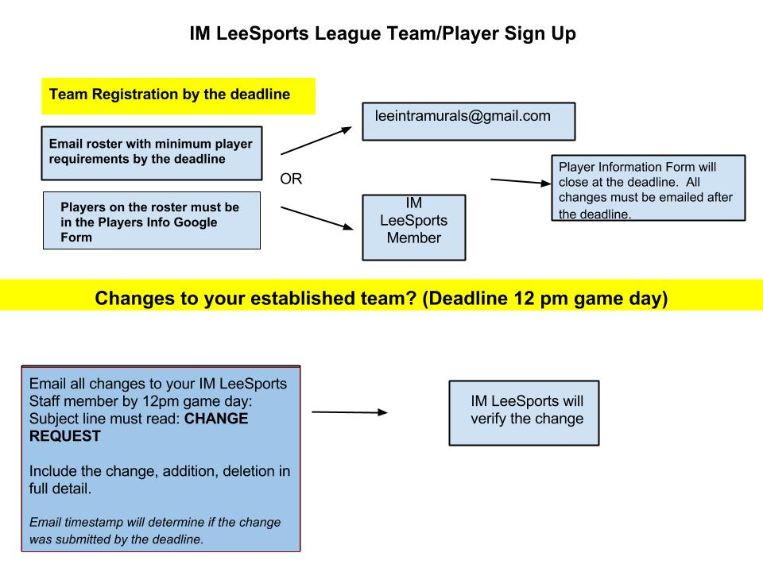

**Eligibility of players generally requires:**

* Validated Student ID card must be shown at check in on every game day. It will be returned at the end of the game day.
* GPA must be 2.0 cumulative or above
* If the team wears their own jerseys they must be numbered and the same color. If not the league will provide the numbered jersey for the game.
* Proper attire must be worn on game day
* Proper athletic shoes must be worn on game day: changes per sport
* Specific sports may require additional equipment: Please see the specific sport tab for the rules
  + Example: Soccer requires shin guards and socks to cover the shin guards
* Player must have completed waiver forms and Advisors submitted to IM LeeSports staff

**IM LEESPORTS TEAM Will:**

* Coordinate the League logistics and update Advisors regularly
* Hold Mandatory Logistics Meetings one week before the league start date on each campus. Will include information about rules, sportsmanship, answer any other questions, preview the brackets, etc.
* Will assist with marketing and recruitment of players by tabling on each campus. The IM LeeSports staff will coordinate with the Advisor.
* Respond within 24 hours to any text or email inquiry from the Campus Advisors
* Provide healthy snacks and water during the one day tournaments. Will provide water during league game days.
* Not carpool the students

**EACH CAMPUS WILL:**

* The Advisor(s) should be the individual who handles all paperwork, inquiries, and attends the games; however they do not have to do all. It is only a recommendation.
* Advisors must report updates to [leeintramurals@gmail.com](mailto:leeintramurals@gmail.com) every Friday (once a week) regarding number of student participants. The Google Players Form may be utilized to keep IM LeeSports updated.
  + ***Cumulative GPA checks and waiver forms should be marked on the google doc by the campuses. IM LeeSports will not be held responsible if a student on another campus plays and does not meet the GPA requirement. IM LeeSports will assume that if the player is listed in the roster and submits the waiver form that they meet all requirements.***
  + ***If an ineligible player (does not meet GPA requirement) is brought to the attention of the IM LeeSports team and IM LeeSports verifies ineligibility then all the games that the ineligible player participated in will result in a forfeit.***
* Each campus will answer questions from their campus. If they cannot answer a question then they will email [leeintramurals@gmail.com](mailto:leeintramurals@gmail.com) or text IM LeeSports Team for further clarification before answering the question. The Inquiry form emailed can also be utilized and IM LeeSports will answer inquiries via that google form.
* Use the IM LeeSports League branding image on their own flyers and market the program. Recommendations are tabling sessions, NSO’s, and presentations in classrooms
* Advisor must attend the Logistics Meeting held on their campus by IM LeeSports
* One or two weeks before the Logistics Meeting, the Advisor should hold an informational meeting. Answer questions, situate their teams, and sign students up.
* Coordinate the room reservations for the Logistics Meetings on the campuses
* Coordinate the reservations for IM LeeSports to table in an outdoor location including a table and chair.
* Responsible for student rides to the games
* Advisor must be present at all games and cannot be players on the team