KAPI‘OLANI COMMUNITY COLLEGE
COMPREHENSIVE INSTRUCTIONAL PROGRAM REVIEW

A.S. DEGREE FOR EDUCATIONAL PARAPROFESSIONALS
2009

Assessment Period: 2006-2009

MISSION STATEMENT 2003-2010 (Approved October 7, 2002 by KCC Faculty Senate)

Kapi’olani Community College...

- is a gathering place where Hawai‘i’s cultural diversity is celebrated, championed and reflected in the students, faculty, staff, administration and curriculum.

- is a nurturing workplace of choice for strong and caring faculty, staff, and administrators committed to a shared vision and set of values.

- strives to be the first choice for education and training for Hawai‘i’s people.

- provides open access, and promotes students’ progress, learning and success with low tuition and high quality instructional programs, student development and support services, and selective areas of excellence and emphasis.

- prepares students to meet rigorous baccalaureate requirements and personal enrichment goals by offering a high quality liberal arts program.

- prepares students to meet rigorous employment and career standards by offering 21st century career programs.

- prepares students for lives of ethical, responsible community involvement by offering opportunities for increased civic engagement.

- leads locally, nationally and internationally in the development of integrated international education through global collaborations.

- uses human, physical, technological and financial resources effectively and efficiently to achieve ambitious educational goals.

- builds partnerships within the University and with other educational, governmental, business, and non-profit organizations to support improved learning from preschool through college and lifelong.

- uses cycles of qualitative and quantitative assessment to document degrees of progress in achieving college goals and objectives.

PROGRAM MISSION STATEMENT

The mission of the Educational Paraprofessional (EDPA) Program is to successfully prepare highly qualified pre-education majors and in-service educational assistants to to work with students with disabilities, deaf and hard-of-hearing students, and students whose English is their Second Language in preK-12 settings.

PART I: EXECUTIVE SUMMARY OF PROGRAM STATUS

This is the first report of the newly developed three-year program review. There are no
recommendations from previous reports to discuss at this time.
PART II: PROGRAM DESCRIPTION

Description

The EDPA Program is part of the Arts and Sciences Division and housed in the Social Sciences Department. The Associate in Science degree for Educational Paraprofessionals has two emphases: Special Education (SPED) and Deaf and Hard of Hearing (DHH). The EDPA Program prepares students to work in a variety of preK-12 settings, as well as other public and private venues that serve students with disabilities and deaf and hard of hearing students, and refines and updates the skills of educational paraprofessionals in the field. The program integrates quality classroom instruction with intensive hands-on learning via service learning, and field/practicum and/or on-the-job experiences.

History

In 2002, KCC made a commitment to preparing teachers and educational paraprofessionals, and created the very first Teacher Preparation Coordinator/Instructor position in the State. With input from the KCC administration, faculty, and students, the TEACH (Teacher Education for All Children in Hawaii) Hawaii Program was “officially” created on November 1, 2003 (see Appendix I for program brochure). Over the years, the TEACH Hawaii Program has fulfilled many different, but related, purposes on campus for the students and the College. The TEACH Hawaii Program (a) offers two-year degree programs for pre-education students and educational paraprofessionals; (b) supports and prepares pre-education students and educational paraprofessionals to successfully achieve an Associate degree and/or transfer to a baccalaureate teacher education program, (c) identifies, advises, and monitors pre-education majors and educational paraprofessionals; (e) develops and offers education courses and opportunities for students; (f) partners with the Hawaii Department of Education (DOE), teacher education institutions, and other community colleges, (g) collaborates with the high schools to create a seamless pathway for students interested in becoming teachers; and (h) organizes all the education initiatives.

On February 20, 2004, the A.S. Degree for Educational Paraprofessionals (EDPA) was approved by the Board of Regents. It was the first of its kind in the State. The degree has two emphases: Special Education & Deaf and Hard of Hearing. The intent of this degree program is to prepare and support the State of Hawaii Department of Education (DOE) educational paraprofessionals (as well as other interested students) to meet the mandates of President Bush's "No Child Left Behind" (NCLB) Act of 2001. This act requires educational paraprofessionals, who are presently employed by DOE, to be “highly qualified.” Qualified educational paraprofessionals are those who have: (a) completed two years of higher education courses (100 level or above), (b) obtained an A.A. or A.S. degree, or (c) completed the required DOE training and passed a statewide assessment exam.

In 2008, the TEACH Hawaii program’s name changed to The Center on Responsive Education (CORE). The name change in 2008 was necessary to reflect its comprehensive teacher preparation support and services to students and educational paraprofessionals. CORE is a group of four KCC programs (Deaf Education, Educational Interpreting, ESOL/Second Language Teaching, & Special Education/Elementary & Secondary Education), which includes the A.S. degree for Educational Paraprofessionals (EDPA). These programs prepare paraprofessionals and educational interpreters, and serving as pathways for pre-education and transfer students. Faculty from various, but closely related disciplines, work together to prepare educational professionals and paraprofessionals to be responsive to individual and group needs—specializing in differentiated instruction and universal design. The CORE partnership provides a supportive, collaborative, and collegial forum for program coordinators/counselors and enables the sharing and consolidation of resources. Working together as a CORE team strengthens and builds capacity and unites faculty working toward common goals. Even though the CORE programs target different focus areas of education, they share common structures and designs (e.g., tactical plan, SLOs) and collaborate individually and collectively with CELTT, Kahikoluamea, Malama Hawaii, STEM, and ESOL to maximize program offerings. CORE partners work together to:
- Anticipate and address workforce needs for teachers, educational assistants, and interpreters.

- Work with Hawaii State DOE to align CORE programs and courses to workforce needs.

- Create a pathway academy for pre-education students.

- Develop and strengthen articulation agreements with UH system campuses, HPU, Chaminade University, Michigan State University, Gallaudet University, and other baccalaureate teacher-education institutions.

- Market CORE and recruit students into the CORE’s teacher preparation programs.

- Improve student recruitment, persistence, completion, and transfer.

- Identify, align, assess, and evaluate program-level student learning outcomes.

- Create opportunities for exchange, training, and research for CORE faculty.

- Submit proposals for competitive federal and state teacher-preparation grants.

- Increase and improve distance learning/ alternative-delivery courses, outreach and support services, and technologies (e-portfolios).

Program Goals

- The EDPA program at Kapi‘olani Community College prepares students for employment in the field of Special Education, working with preK-12 students with disabilities and deaf and hard-of-hearing students in various settings.

- The program serves in-service educational paraprofessionals by updating and
refining their job skills.

Occupations
The EDPA Program prepares students to work in a variety of preK-12 settings, as well as other public and private venues that serve students with disabilities and deaf and hard of hearing students. Graduates from this program can be employed as:
- Educational /Teacher Assistants
- Parent Community Network Coordinators
- School Support Staff
- Family Advocates
- Parent-Child-Family Facilitators
- Educator in Various Childhood Programs
- Skills Trainers
- Specialized Tutors
Program SLOs
Special Education Emphasis

Upon successful completion of the A.S. degree Educational Paraprofessional with a specialization in Special Education, students should be able to:
- Use informed decision making to function effectively in the classroom, school, local, and professional communities.

- Use communication skills to work effectively with students, their families, school administrators, teachers, staff, and other related personnel.

- Use instructional and behavioral management strategies to facilitate a positive learning environment for students.

- Demonstrate professionalism and ethical practices in the classroom, school, local, and professional communities.

- Demonstrate knowledge and skills specific to the instruction and support of students with disabilities in a variety of settings.

- Demonstrate elementary skills in American Sign Language and English.

Deaf & Hard of Hearing Emphasis

Upon successful completion of the A.S. degree Educational Paraprofessional with a specialization in Deaf and Hard of Hearing, students should be able to:
- Use informed decision making to function effectively in the classroom, school, local, and professional communities.

- Use communication skills to work effectively with students, their families, school administrators, teachers, staff, and other related personnel.

- Use instructional and behavioral management strategies to facilitate a positive learning environment for students.

- Demonstrate professionalism and ethical practices in the classroom, school, local, and professional communities.

- Demonstrate knowledge and skills specific to the instruction and support of deaf and hard of hearing in a variety of settings.

- Demonstrate intermediate skills in American Sign Language and English.

Admission and Degree Requirements

There are no specific admission requirements for the EDPA Program, aside from taking the COMPASS test for appropriate placement into math and English courses. The program has two emphases: Special Education (SPED) and Deaf and Hard of Hearing (DHH). Both emphases require 60 and 61 credits respectively (see grids below). Prior to completion of the program, students must successfully complete the SPED or DEAF 294 Practicum Seminar course, which includes 150 hours of field experience, a professional portfolio, mentor teacher evaluations, and a suitability assessment. Graduates of the program are able to transfer to a teacher education baccalaureate program and/or enter the workforce as an entry-level educational paraprofessional or related position.

A.S. Degree for Educational Paraprofessionals
Kapi`olani Community College
SPECIAL EDUCATION EMPHASIS
CURRENT PROGRAM COURSES (Effective Fall 2007)
Course Alpha, Number | GENERAL EDUCATION COURSES (16 Credits) | Number of Credits
Any AS/NS Biological Science Course w/Lab | Any AS/NS Biological Science Course w/Lab (BIO 101, 103, 130, BOT 101, 130, MICR 140, PHYL 160, ZOO 141, 142, 200) | 4
ENG 100/ESL 100 | Composition I/Expository Writing: A Guided Approach | 3
FAMR 230 | Survey of Human Growth & Development | 3
*HWST 107  or HIST 284 or 288 | Hawaii: Center of the Pacific  or Hawaiian History or the Survey of Pacific Islands History | 3
*Math 111 or Math 100 (or any other higher level mathematical course) or Phil 110 | Mathematics for Elementary Teachers I or Survey of Mathematics (or any other higher level) or Introduction to Deductive Logic | 3
 | SUPPORT COURSES (3 Credits)
*ENG 102 or MATH 112 or SP 151 or 181 | College Reading Skills or Mathematics for Elementary Teachers II or Oral Communications Techniques or Interpersonal Communication | 3
 | ELECTIVES (6 Credits)
ART 101 or MUS 253 | Introduction to Visual Arts/Basics of Music | 3
Any AS/NS Physical Science Course | Any AS/NS Physical Science Course (ASTRO 110, 280, CHEM 100, 151, 161, GG 103, GEOG 101, OCN 201, PHYS 100, 122, 151) | 3
*REL 150 or any other AS Global Multicultural Perspectives Course | Introduction the World’s Major Religion or Global Multicultural Perspectives Course | 3
SOC 214, 218, or 231 | Introduction to Race & Ethnic Relations or Introduction to Social Problems or Introduction to Juvenile Delinquency | 3
ED 125 | Family, School, & Community Partnerships I | 3
 | EDUCATIONAL PARAPROFESSIONAL COURSES (35 Credits)
ASL 101 | Elementary American Sign Language I | 4
ASL 102 | Elementary American Sign Language II | 4
DEAF 101 | Deaf Studies | 3
DEAF 201 | Educational Principles & Practices | 3
ED 126 | Family, School, & Community Partnerships II | 3
ED 260 | Positive Behavior Interventions & Supports | 3
ED 170 | Computer Applications in the Classroom | 3
ED 285 | Introduction to Classroom Management & The Instructional Process | 3
ED 286 | Working with Populations with Special Needs I | 3
ED 287 | Working with Populations with Special Needs II | 3
ED 294 | Practice Seminar (Special Education Emphasis) | 3
 | ASSOCIATE IN SCIENCE DEGREE | 60
* = Note: Student’s choices of courses will depend on their future goals and individual needs.

A.S. Degree for Educational Paraprofessionals
Kapi`olani Community College
DEAF & HARD OF HEARING EMPHASIS
CURRENT PROGRAM GRID (Effective Fall 2007)
Course Alpha, Number | GENERAL EDUCATION COURSES (15 Credits) | Number of Credits
Eng 100/ESL 100 | Composition I/Expository Writing: A Guided Approach | 3
Math 111 or Math 100 | Mathematics for Elementary Teachers I (effective Fall 2007: level II) or Survey of Mathematics (or any other higher level mathematical course) | 3
PHYL 160 or any Natural Science Course | Sleep Science or any other Natural Science course | 3
FAMR 230 | Survey of Human Growth & Development | 3
HAWST 107 or HIST 284 or 288 | Hawaii: Center of the Pacific or Hawaiian History | 3
 | SUPPORT COURSES (6 Credits)
PSY 100, SOC 100, or SOC 231 | Survey of Psychology, or Introduction to the Study of Society, or Introduction to Juvenile Delinquency | 3
SP 151 | Personal and Public Speech | 3
 | ELECTIVE (3 Credits)
ART 101 or | Introduction to the Visual Arts | 3
ED 125 or | Family, School and Community Partnerships I | 3
ED 126 or | Family, School and Community Partnerships II | 3
ED 170 or | Computer Applications in the Classroom | 3
 | EDUCATIONAL PARAPROFESSIONAL COURSES (37 Credits)
ASL 101 | Elementary American Sign Language I | 4
ASL 102 | Elementary American Sign Language II | 4
ASL 201 | Intermediate American Sign Language I | 4
ASL 202 | Intermediate American Sign Language II | 4
ED 285 | Introduction to Classroom Management & The Instructional Process | 3
ED 286 | Working with Populations with Special Needs I | 3
ED 287 | Working with Populations with Special Needs II | 3
DEAF 101 | Deaf Studies | 3
DEAF 201 | Educational Principles and Practices | 3
DEAF 202 | Effective Teaching Strategies | 3
DEAF 294 | Practicum | 3
 | ASSOCIATE IN SCIENCE (A.S.) DEGREE | 61

Advising and Counseling: Students are asked to participate in an intake meeting prior to enrolling in the EDPA program. At this meeting, the student’s prior knowledge, experience, interest and motivation are assessed. The student then works with the program counselors/advisors to fill out an individual plan for completion of the program courses. Program advising is provided throughout the students’ enrollment in the program. One of the counselors/advisors is fluent in American Sign Language in order to work with deaf and hard of hearing students in the program.
Faculty and Staff

Dale Peterson, Administrative Assistant, Deaf and Hard of Hearing (DHH) & Educational Interpreting (EI) Programs

Judy Coryell, Professor, KCC Deaf Center & Gallaudet University Regional Center Director

Jan Fried, Professor, Coordinator & Instructor of the EI Program
Instructor

Kristie Malterre, Arts & Sciences and Teacher Preparation Program Counselor

Layce Reed, Deaf & Hard of Hearing (DHH) Emphasis & EI Program Counselor

Mary Hattori, Assistant Professor, Coordinator of the Center of Excellence in Learning, Teaching, and Technology, & ED 170 Instructor
Shawn Ford, Instructor, Coordinator of the Second Language Teaching (SLT) Program

Veronica Ogata, Assistant Professor, ED/SPED Instructor, Teacher Preparation Coordinator

Resources

Since its inception, the EDPA Program has had and continue to have the full support of the College, its administration – Chancellor, Vice Chancellor of Academic Affairs, Dean of Arts & Sciences, Dean of Student Services – as well as the support of the Office of Institutional Research, and the Departments of Social Sciences and Languages, Linguistics, and Literature, along with the Gallaudet Regional Center, the KCC Deaf Center, the Center for Excellence in Learning, Teaching and Technology (CELTT), the Science, Teaching, Engineering, & Mathematics (STEM) Center, and the Kahikoluamea, Malama Hawaii, and ESOL Programs. Over the years, these entities have provided the EDPA program with physical, financial, and human resources. Additionally, the EDPA program faculty continually seek, apply for, and secure external funding for program development and improvement.
The EDPA program takes full advantage of existing student academic planning, counseling and support services available through the College and the support services provided by the Special Student Services Office and Gallaudet University Regional Center, which address the needs of students with disabilities, including those specifically designed to meet the needs of deaf and hard of hearing students.
All program courses required for the A.S. EDPA degree are taught by KCC faculty. Program faculty are sufficient to maintain the program at this time and were employed by the College according to established recruitment and hiring procedures. All program faculty, including the program counselors, are KCC employees, allowing the College to exercise absolute control over the quality of the program. The Dean of Arts and Sciences oversees the program, which is supported by faculty in two departments: the Social Sciences department and the department of Languages, Linguistics and Literature. Furthermore, faculty for each area of emphasis within the program have specific expertise in that area. Faculty teaching the ASL courses and the DEAF courses have unique skills and qualifications to teach those courses that are not offered at any other institution throughout the state.

Articulation Agreements

Articulation Agreement with the DOE & the UHCC System

EDPA program faculty collaborated with the faculty of the Teacher Education Program at Leeward Community College (LCC) and representatives from the Hawaii State Department of Education (HIDOE) to develop an articulation agreement between the DOE and the UHCC system. The primary purpose of this articulation agreement was to provide a mechanism which enabled the DOE high school students, who were interested in enrolling at KCC and LCC as EDPA majors, to receive college credits for mastery of standards/student learning outcomes gained in certain courses (see table below) taken at the high school level. The following table outlines the articulated courses covered by the Agreement. The credit and contact hours are shown in parentheses.

State of Hawai‘i Department of Education (DOE) | Kapi‘olani Community College | Leeward Community College
TPN 7220 Teacher Education (year)  TPN 7221 Teacher Education A (semester)  TPN 7222 Teacher Education B (semester) | ED 100 Introduction to Education (3 credits) | ED 100 Introduction to Education (3 credits)

This agreement provided the faculty of high schools, KCC, and LCC the ability to: (a) develop a pipeline through which better prepared students may progress; (b) align programs and courses more effectively to meet workforce needs; and (c) improve communication and trust among institutions.

This articulation agreement also worked toward standardizing ED 285, ED 286, and ED 287 between LCC and KCC. Prior to this agreement, instructors who taught these courses not only had different course objectives and competencies, but were also covering different content material. With this agreement, KCC and LCC’s course descriptions, objectives, and competencies would be completely aligned. Revisions are still being made to this agreement. It should be finalized in the Spring of 2010 and fully implemented by the summer (see the Articulation Agreement).

Articulation Agreements with Chaminade University, & the UHM College of Education
The EDPA program faculty and the Vice Chancellor of Academic Affairs worked with the Dean of the College of Education from Chaminade University and the UHM to create separate, but similar articulation agreements. The purpose of these agreements were to provide a two-year alternative route for KCC students, who completed the A.S. Degree for Educational Paraprofessionals-Special Education Emphasis, to earn a Bachelor of Education degree in Special Education from Chaminade University and a Bachelor of Education with certifications in Special Education & Elementary Education. Both of these agreements serve finalized in the Fall of 2008 and Summer of 2009, respectively.
Memorandum of Agreement with the DOE
The EDPA program faculty and the Vice Chancellor of Academic Affairs partnered with the head of the Department of Education (DOE) Professional Development Branch for Educational Paraprofessionals to establish a memorandum of agreement (MOA). The primary purpose of this MOA was to support educational paraprofessionals employed by the DOE to obtain the A.S. Degree for Educational Paraprofessionals. In short, the MOA stipulates that the DOE will pay for two-thirds of the educational paraprofessional’s tuition if he/she enrolled in courses that will help him/her to obtain the A.S. degree for Educational Paraprofessionals. This was another alternative to: (a) assisting educational paraprofessionals in becoming qualified; (b) providing them with a career pathway to becoming special education teachers; (c) responding to the shortage of teachers and educational paraprofessionals; and (d) helping the educational paraprofessionals move up the DOE career ladder.
Advisory Committee
The alignment of program outcomes and industry need is monitored by the EDPA Advisory Board, which includes members of the academic as well as professional community:

Community Representatives
Sydney Freitas, HI DOE | Joy Okimoto, HI DOE
Faculty Representatives
Judy Coryell, KCC  Jan Fried, KCC  Patricia Sheehey UHM | Veronica Ogata, KCC  Shawn Ford, KCC  David Grossman, Chaminade
Student Representatives
Danette Beams  Evelyn Ganialongo | Effie Egan  Katie Shiroma
Campus Representatives
Dale Peterson, Administrative Assistant | Layce Reed, Academic Advisor
Campus Administration
Leon Richards, Chancellor | Louise Pagotto, Vice Chancellor

Distance Education Courses

All of the program courses for the DHH emphasis are conducted on the college campus and through the use of Hawai`i’s Interactive Television System (HITS). Most of the SPED emphasis courses are conducted face to face. ED 285 is a hybrid distance education course, where students receive lecture information via Olelo Community Television, engage in discussions and complete assignments on-line. Currently, ED 286 is being offered for the first time on-line and ED 287 will be offered as a distance education course in the Summer of 2010.

PART III: QUANTITATIVE INDICATORS FOR PROGRAM REVIEW

Please see 2006-2009 Annual Program Reviews for data.
PART IV: ASSESSMENT RESULTS CHART FOR PROGRAM SLOs
The EDPA program is in the beginning stages of assessing their program SLOs. In the Fall of 2009, program faculty assessed SLO #3. See charts below.
SPED & DHH Emphases
Program SLOs |  | Evidence of Industry Validation | Assessment Strategy/instrument |  | Results of Program Assessment |  | Plan for Improvement
SLO #3: Use instructional and behavioral management strategies to facilitate a positive learning environment for students. |  | Approved by Advisory Board Members on November 2008. | SLO #3 - Rubric (see attached.)  Mentor teachers' and instructors' evaluations and comments.  Student evaluations on performance.  Selected Portfolio Items. |  | It is clear that all of the students met this SLO.  Score (0-2)*:  0 - Unacceptable (0)  1 - Acceptable (0)  2 - Target - 100%  (4 students in ED/DEAF 294 - Practicum Seminar) |  | Step 1: Improve Mentor Teacher's & Instructors' Evaluations to clearly and specifically assess for the items outlined in the rubric.  Step 2: Improve Student evaluations to clearly and specifically assess for the items outlined in the rubric.  Step 3: Require specific portfolio items to clearly and specifically assess for the items outlined in the rubric.  Step 4: Re-write SLO #3 to separate instructional and behavioral management strategies.  Step 5: Re-assess SLO #3 in Spring 2010 with implemented improvements.
RUBRIC (SLO #3)  Category | Target (2) |  |  | Acceptable (1) |  | Unacceptable (0)
Planning instruction and designing learning experiences for students | Consistently designs clear and developmentally appropriate instructional and behavioral goals for student learning. Purposefully plans for appropriate instruction and behavior, selecting and adapting a variety of appropriate strategies and materials for content delivery and behavior management. |  |  | Develops goals for student learning and behaviors. Is able to plan for appropriate instruction and behavior, selecting and adapting strategies and materials for content delivery and behavior management. |  | Is unable to develop appropriate goals for student learning and behaviors and/or plan for appropriate instruction and student behaviors. Is ineffective in selecting and adapting strategies and materials for content delivery and behavior management.
Creating and maintaining effective environments for student learning | Maximizes instructional time by setting clear and appropriate expectations for academic and social behavior and consistently maintaining a positive climate for learning. |  |  | Establishes clear and appropriate expectations for academic and social behavior and generally maintains a positive climate for learning. Able to manage instructional time. |  | Has unclear expectations for classroom behavior. Learning environment may be compromised. Does not use instructional time effectively.
Engaging and supporting student learning | Captures student attention and engages them in student-centered learning activities. Ensures active and equitable participation and maintain behavior of all students. |  |  | Engages and maintain behavior for most students in learning activities that are student-centered. |  | Is unable to establish and/or maintain student attention, behaviors, or participation. Instructional approach is primarily teacher-centered.
Making subject matter comprehensible to students | Effectively and consistently differentiates instruction and uses appropriate behavior management strategies to address diverse learning needs of a variety of student. Utilizes a wide range of subject-specific pedagogical skills. |  |  | Considers student characteristics in delivering instruction, applying appropriate subject-specific pedagogical skills, and using behavior management strategies. |  | Is unable to differentiate instruction to address specific student learning needs. Has limited knowledge or application of pedagogical skills and behavior management techniques.
Assessing student learning | Frequently monitors student learning through a variety of formative and summative assessment tools. Provides students with detailed feedback as part of the instructional and behavioral process. Involves students in the evaluation of their own learning and behavior management. Consistently adapts instruction and behavior plan based on student assessment data. |  |  | Monitors student learning through formative and summative assessment tools. Provides students with feedback as part of the instructional process. Is able to use student assessment data to adapt instruction and behavior techniques. |  | Is ineffective in assessing student progress. Provides students with infrequent and/or unclear feedback on performance. Is unable to use student assessment data to adapt instruction and behavior plan.

Alignment of courses to program SLOs | Use informed decision making to function effectively in the classroom, school, local, and professional communities. | Use communication skills to work effectively with students, their families, school administrators, teachers, staff, and other related personnel. | Use instructional & behavioral management strategies to facilitate a positive learning environment for students. | Demonstrate professionalism and ethical practices in the classroom, school, local, & professional communities. | Demonstrate knowledge and skills specific to the instruction and support of students with disabilities in a variety of settings. | Demonstrate elementary skills in American Sign Language and English.
ASL 101 | √ | √ |  |  |  | √
ASL 102 | √ | √ |  |  |  | √
ASL 201 | √ | √ |  |  |  | √
ASL 202 | √ | √ |  |  |  | √
DEAF 101 | √ | √
DEAF 201 | √ | √ | √ | √ | √
DEAF 202 | √ | √ | √ | √ | √
ED 126 | √ | √ |  | √
ED 151 | √ | √ | √ | √ | √
ED 260 | √ | √ | √ | √ | √
ED 285 | √ | √ | √ | √ | √
ED 286 | √ | √ | √ | √ | √

Please see Part VIII: Future Plans to review the assessment plan for the remaining EDPA program SLOs.
PART V: CURRICULUM REVISION AND REVIEW
Since the A.S. EDPA Program was approved in February 2004, modifications were made. In Spring of 2007, an Action Request Memorandum (ARM) to request the following changes to the A.S. Degree for Educational Paraprofessionals: (a) offering more options for general education requirements, (b) deleting a few program competencies and courses, (c) adding new program competencies and courses (d) modifying existing program competencies, and (e) establishing certificate programs for the special education (SPED) emphasis. General education, support, and elective courses have been added to expand options; ED 250 and 251 (Autism I & II) have been deleted; and ED 125 (Family, School, & Community Partnerships) and ED 170 (Computer Applications for the Classroom) have been added and developed specifically for educational paraprofessionals presently employed in the DOE.

These updated changes aligned the A.S. degree program to what is currently expected of educational paraprofessionals working in special education classrooms. The alignment also increases the employability of our program graduates.

Certificate programs have also been added to provide employed educational paraprofessionals with “stop points,” particularly for those who are not able to complete the A.S. degree, but need the certificates to move up the career ladder.

In 2009, all EDPA courses went through a 5-year review, were updated, and approved. All the course titles were changed to simplify and make the title clearer for students, and to align the course titles with other teacher preparation courses in special education. The comment “intended for DOE educational paraprofessionals, others may enroll on a space-available basis” was deleted because the comment no longer applied. The courses are now open to all students.

There were no major changes to the content material; however, minor and updated rewording of the course description and reorganization of the content were made. The new order in which content material are covered is intended as a pedagogical improvement and based on 5 years of experience in teaching the course.

PART VI: SURVEY RESULTS
Student Satisfaction
Table 1-3 reflects student evaluations of the instructor teaching the three program foundation courses (ED 285, 286, and 287) over a period of three to four semesters. Overall data for each of the courses reveal that the students felt that the instructor was prepared, knowledgeable, fostered independent learning, and maintained a good relationship with the students.
Table 1. Consistent Students: ED 285 - Fall 2005, Summer 2006, Summer 2007
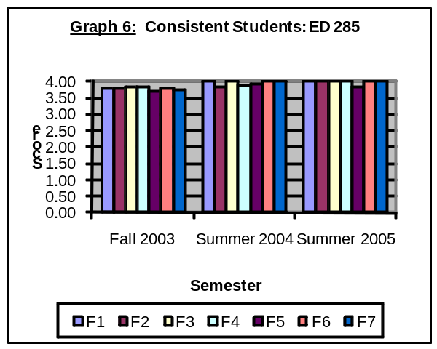
*Note: Only mean scores are shown. The overall column represents the combined
Factors | Area | F  2005 | S  2006 | S  2007 | Overall
Factor 1 | Course Presentation | 3.82 | 4.00 | 4.00 | 3.94
Factor 2 | Independent Learning | 3.79 | 3.83 | 4.00 | 3.87
Factor 3 | Preparation/Knowledge | 3.85 | 4.00 | 4.00 | 3.95
Factor 4 | Relationship w/ Students | 3.83 | 3.89 | 4.00 | 3.91
Factor 5 | Grading Policies | 3.70 | 3.92 | 3.83 | 3.82
Factor 6 | Availability | 3.80 | 4.00 | 4.00 | 3.93
Factor 7 | Course Objectives | 3.74 | 4.00 | 4.00 | 3.91
average of mean scores for the semesters indicated. Scores are measured on a 4.0 scale.
Table 2. Consistent Students: ED 286 – Spring 2005, Spring 2006, Spring 2007
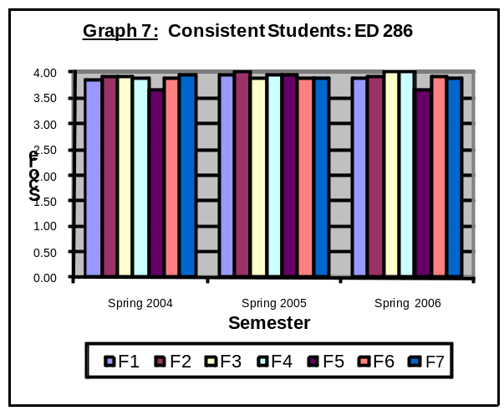
Factors | Area | S  2006 | S.  2007 | S  2008 | Overall
Factor 1 | Course Presentation | 3.84 | 3.96 | 3.90 | 3.90
Factor 2 | Independent Learning | 3.91 | 4.00 | 3.92 | 3.94
Factor 3 | Preparation/knowledge | 3.91 | 3.88 | 4.00 | 3.93
Factor 4 | Relationship w/ Students | 3.90 | 3.96 | 4.00 | 3.95
Factor 5 | Grading Policies | 3.67 | 3.94 | 3.65 | 3.75
Factor 6 | Availability | 3.88 | 3.88 | 3.92 | 3.89
Factor 7 | Course objectives | 3.94 | 3.88 | 3.88 | 3.90
*Note: Only mean scores are shown. The overall column represents the combined
average of mean scores for the semesters indicated. Scores are measured on a 4.0 scale.

Table 3. Consistent Students: ED 287 – Fall 2004, Fall 2005, Fall 2006
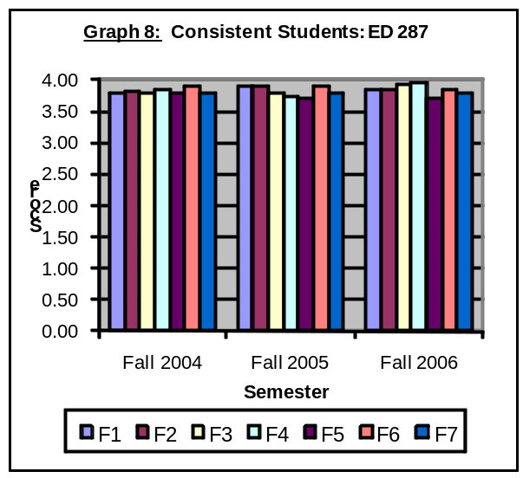
Factors | Area | F  2004 | F  2005 | F  2006 | Overall
Factor 1 | Course Presentation | 3.78 | 3.90 | 3.86 | 3.84
Factor 2 | Independent Learning | 3.83 | 3.90 | 3.86 | 3.86
Factor 3 | Preparation/Knowledge | 3.78 | 3.80 | 3.93 | 3.84
Factor 4 | Relationship w/ Students | 3.86 | 3.73 | 3.95 | 3.85
Factor 5 | Grading Policies | 3.78 | 3.70 | 3.71 | 3.73
Factor 6 | Availability | 3.89 | 3.90 | 3.86 | 3.88
Factor 7 | Course objectives | 3.78 | 3.80 | 3.79 | 3.79
*Note: Only mean scores are shown. The overall column represents the combined
average of mean scores for the semesters indicated. Scores are measured on a 4.0 scale.
Furthermore, the program has solicited a measure of students’ satisfaction via focus groups in June 2005, May 2005, February 2006 and October 2007. During the focus group meetings, students were asked directed open-ended questions about their satisfaction with the program and given an opportunity to offer suggestions for improvement. The meetings were run by the EDPA Program Faculty. Results of the students input were compiled and shared with the faculty. Students shared that they have been impressed with the overall program, pleased that they have the opportunity to earn an A.S. degree in this field and that the opportunity has been extended to students from the neighbor islands. They are also very pleased with the quality of the faculty, the content of the courses, and the mentoring offered through the program. Some examples of the changes implemented due to student feedback are: (a) better communication from faculty to student and from program to students; (b) more feedback regarding student progress prior to grading; and more opportunities to practice their ASL and SPED skills.
Furthermore, according to the 2006 & 2007 Annual Program Review for the A.S. for Educational Paraprofessionals, the score for the area of student satisfaction was 4.0, which was above the healthy indicator set for that year (3.0). (See Figure 1.1 below)

Student Testimonials:
Student email response to project staff after receiving the 2006-07 award for “Excellence in Service and Learning” for providing 82 hours of sign language interpreting and tutoring for DHH students and students in SPED, and reflecting on his personal growth and learning in an essay:
I haven't checked my e-mail account in quite some time and was surprised to learn that I had been recognized for the "Excellence in Service and Learning Award". I wasn't even aware that my name had been submitted. It is with mild reluctance that I will be accepting this award for I know beyond a shadow of a doubt that I would never have been able to accomplish these achievements without the expert guidance and tutelage from you and all the others involved with the EIA project. My only hope is that you are able to share in the joy that I feel, for it is as much your award as it is mine. Thank you for being a part of my life and thank you for helping me to become the man whom I am today. It is OUR award. Congratulations to YOU on a job well done!
A student graduation message to the Project staff:
“Aloha, I just wanted to thank all of you for the encouragement and support you have given me these last two years. I had such a wonderful experience at KCC and that is due to all of you. I am grateful for all of your hard work in helping me to grow. There were times when I felt that I was failing but, you all had incredible patience and understanding and would not give up on me and in turn gave me more drive to succeed. You have given me a valuable gift of a wonderful education and I will forever be grateful!! Thank You.”
Occupational Placement
To date, the courses offered at KCC (and Leeward Community College) has brought into the UH system, more than 100 educational paraprofessionals who are refining and updating their skills to better serve the students at their respective schools, and several hundred (approximately 300) pre-education majors who are motivated to earn a bachelor’s degree in Elementary Education/Special Education at a partnering teacher education baccalaureate program. EDPA Program graduates (a) are currently pursuing a bachelor’s degree in Education, (b) have been hired by the HIDOE as part-time or full-time educational paraprofessionals, or (c) have completed an undergraduate teacher education program and are employed as SPED teachers.

Employer Satisfaction
EDPA program faculty developed an Employer Satisfaction Survey to evaluate the effectiveness of the A.S. Degree Program for Educational Paraprofessionals. Program faculty wanted to determine (a) how satisfied the principals and teachers were with the program students’ and/or graduates’ classroom performance, teaching skills, and professional conduct; (b) what program changes and improvements, if any, needed to be made in order to align with employment standards; and (c) if employers would hire EDPA program graduates. The following tables and graphs depict the results from a few of the survey questions.
- Ability to demonstrate, produce, and maintain quality work:

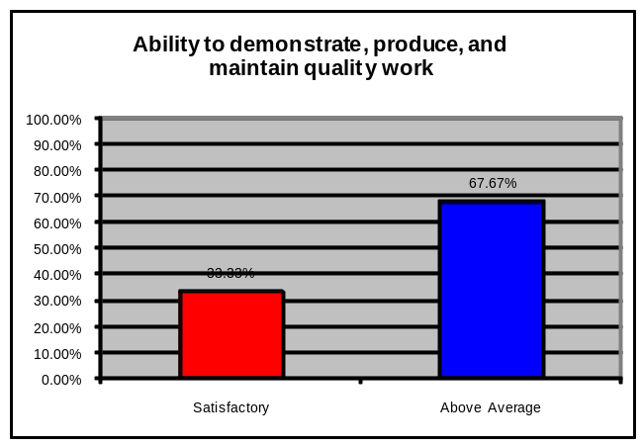
Option | Count | Percent
Satisfactory | 4 | 33.33%
Above Average | 8 | 67.67%
Total | 12 | 100.0%
Total Responses | 12

- Ability to demonstrate ethical standards and behaviors:

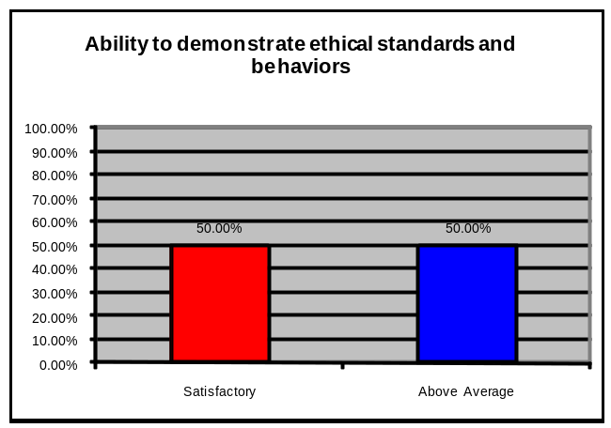
Option | Count | Percent
Satisfactory | 6 | 50.00%
Above Average | 6 | 50.00%
Total | 12 | 100.0%
Total Responses | 12

- If you were in a position to do so, would you hire graduates of KCC in the future?

Option | Count | 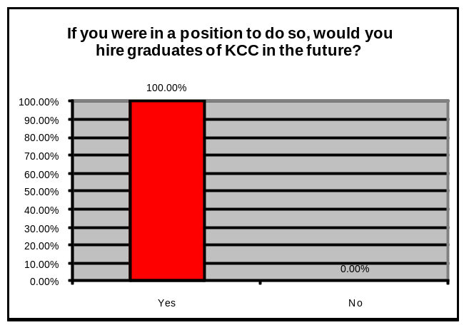Percent
Yes | 12 | 100.00%
Total | 12 | 100.0%
Total Responses | 12

Do you have any other comments you would like to make about students/graduates of KCC’s A.S. Degree for Educational Paraprofessionals?

- So far I am impressed by the caliber of students that are involved in the program
- Well trained, responsible, and dependable.
- Very enthusiastic and works well with students of different levels and abilities.

PART VII: ANALYSIS OF PROGRAM
Alignment with Mission & Strategic Plan
The EDPA program supports the accomplishment of the College’s mission by "preparing students to meet rigorous baccalaureate requirements and rigorous employment and career standards by offering 21st century career programs” and by building partnerships within the University and with other educational, governmental, business, and non-profit organizations to support improved learning from preschool through college and lifelong.”
The EDPA program also directly aligns with the College’s 2003-2010 Strategic Plan, specifically Goal 2 and has accomplished Objective1, and Action Strategies 3, 5, 8, 10, 11, and 13.

Goal 2 - To Build A Learning, Partnering, and Service Network for Student Success
Objective 1: Strengthen intercampus collaboration between and among all UH system institutions, the State Department of Education, and the private and non-profit sectors in true partnerships of equals.

Action Strategies:
- With the equal involvement of faculty at all system campuses, develop an efficient articulation process based on trust among faculties and commitment to shared student learning outcomes; develop and implement a system-wide articulation policy that accepts the decisions of individual campuses in designating core courses.

- Through a five-year grant from the US Department of Education and in collaboration with the Hawaii DOE, the Educational Interpreters and Assistants Preparation (EIA) Project will develop Associates degree programs for those wishing to become educational assistants or educational interpreters to work with deaf and hard of hearing students in the K-12 setting.

- Deepen partnerships with feeder K-12 schools by providing tutors and mentors through the service learning emphasis. These tutors and mentors can be recruited from the large pool of Education majors at the College.

- Involve K – 12 students and faculty in events and activities with the College's students and faculty and with our industry partners.

- Develop collaborative strategies that increase the college going rate of public high school graduates.

- Develop a Campus Advisory Group including representatives from the State Department of Education, and the private and non-profits sectors, to improve access and success for high school graduates.
The EDPA Program also directly aligns with the UH Community Colleges’ strategic plan, specifically Goal C and have achieved (and continue to meet) the following Action Strategies.
Goal C - To promote workforce and economic development by responding quickly with education and training programs to meet changing workforce requirements, by developing partnerships with [industry] providers by offering selected degrees in response to demonstrated market demands.
Action Strategies:
- Make increased use of internships, co-op education, and other workplace to provide students with real-life experiences.

- Respond quickly with education and training to meet emerging economic opportunities.

- Develop strategic partnerships with K-12 and post-secondary education, and training providers to better respond to evolving workforce education and training requirements.

The EDPA program faculty have consistently aimed to enrich the college’s Teacher Preparation Program by ensuring that the EDPA program’s purposes and objectives are appropriate to the functions of the College and University and are achieved with quality.
Strengths and Weaknesses
Overall, the Educational Paraprofessional Program is "cautionary.” For a relatively new program, the efficiency and effectiveness indicators of the Educational Paraprofessional Program reflect the newness of the program. They are low, but gradually increasing. As the State career advancement program develops and requires paraprofessionals to complete education college courses, the demand for the program will increase.
Strengths:
The demand for educational paraprofessionals is very high. Jobs are available for all students in the program. Most of the data elements indicate that the program is in fact growing, albeit at a very slow pace. Part of the reason for the slow growth is that the DOE has changed its requirements for continued employment from obtaining an A.S./A.A. degree or 48 college credits to passing a national standardized assessment. However, these numbers may change in the upcoming year as the DOE is putting in place a career advancement program for paraprofessionals that will require them to take college level courses in order to advance in salary. Another reason is that the majority of majors are incumbent workers who are limited in the number of classes that they can take in any given semester. In addition, in regards to the seven areas for the Perkins Industry Standards (# 21-27), the Educational Paraprofessional Program met and exceeded four of the standards – academic achievement, vocational achievement, placement employment/education, and non-traditional participation.
Weaknesses:
The program has a small number of majors, which impacts class size as well as number of graduates. Student persistence also saw a small decline as did the completion and non-traditional completion and the retention in employment rates. The retention in employment rate is at 75% vs. the state standard of 92%. This indicates that program graduates are not staying in their jobs for the required length of time. This could be due to reasons such as: (a) deciding to pursue a degree in teacher education, (b) moving to another state, (c) transferring to a private school, or (d) changing schools or school districts.
Quality of Student Learning
Regular assessment of the quality of student learning in the EDPA program is measured by the learning outcomes for each course, which are outlined in the course syllabi. Specific assignments are tied to those outcomes. A detailed explanation of the method for evaluation and the course grading scale are included in the course syllabi. Students are required to participate in the program’s practicum seminar course, which is the capstone course of the program. Students are required to work in preK-12 classrooms with students with disabilities and/or deaf and hard of hearing students at two different sites and receive feedback from their supervisors at each of these sites. The students are evaluated on their Professionalism, Knowledge, Communication and Teaching Skills with a scale of Superior (4), Good (3), Average (2), and Concern (1). The results of the evaluation on 11 students enrolled in the course for the Spring semester of 2007 are as follows:
Characteristics Average Score
Professionalism 3.875
Knowledge 3.675
Communication 3.6
Teaching Skills 3.7
The results demonstrate that supervisors at the practicum location were very pleased with the quality of the students who will be graduating from the EDPA program. Average scores in all areas were between good and superior. Communication scores were the most variable with students scoring a 2.75 cumulative in that category and other students scoring a solid 4.0. Program faculty are aware that some students will not be able to be fully competent in American Sign Language with only four semesters of study. For that reason, additional service learning and mentoring requirements are built into the program to enhance students’ language skills. Nonetheless, some students will still require more time working with deaf students to improve their quality of language skills.
Resource Sufficiency
Presently, there are no major resource insufficiencies. Please see Part II: Program Description, under Resources, to see how the EDPA program is being supported by the College and other entities.
Part VIII: ACTION & ASSESSMENT PLANS
The CORE (Center on Responsive Education) faculty (which includes EDPA program faculty developed a three-year tactical plan to not only address the weaknesses of the EDPA program, but to improve the outcomes of all teacher preparation programs and initiatives at the College. The CORE’s tactical plan directly aligns with the College’s and the UH System’s tactical plans.
CORE TACTICAL PLAN 2010-2013

Outcome 1: Education Capital
Objective 1:
To support the College’s going rate of high school, immigrant, multi-lingual, Pacific Island, and Native Hawaiian students, particularly those from underserved regions, by increasing enrollment in CORE’s 21st Century Teacher Preparation Programs by 10% annually.
Action 1: Recruit these students to the CORE’s teacher preparation programs.

Action 2: Build and maintain partnerships with students, families, communities, and the Hawaii State DOE.

Objective 2:
To increase the re-enrollment and completion of high school, immigrant, multi-lingual, Pacific Island, and Native Hawaiian students, particularly those from underserved regions, enrolled in CORE’s 21st Century Teacher Preparation Programs by 10% annually.

Action 1: Increase and improve distance learning/ alternative-delivery courses, outreach and support services, and technologies (e-portfolios).

Action 2: Stay abreast of and use engaging pedagogies involving service learning/ experiential opportunities.

Action 3: Create a pathway academy for pre-education students.

Action 4: Identify, align, assess, and evaluate program-level student learning outcomes.

Objective 3:

To increase the transfer rate of high school, immigrant, multi-lingual, Pacific Island, and Native Hawaiian students, particularly those from underserved regions, enrolled in CORE’s 21st Century Teacher Preparation Programs by 10% annually.

Action 1: Create a pathway academy for pre-education students.

Action 2: Develop and strengthen articulation agreements with UH system campuses, HPU, Chaminade University, and other baccalaureate teacher-education institutions.

Outcome 2: Economic Contribution

Objective 1:
To support extramural funding to the College and the State through CORE’s 21st Century Teacher Preparation Programs by $100,000 annually.

Action 1: Anticipate and address workforce needs for teachers and educational assistants.

Action 2: Submit proposals for competitive federal and state teacher-preparation grants.

Action 3: Establish and expand partnerships with the K-12 sector, related industries, local businesses, community leaders, and national, international, and Pacific Island organizations, to share teacher-training resources.

Action 5: Support the transition of students through a seamless P-20 pipeline into teaching careers.

Action 6: Market CORE as the Pacific’s premiere 21st Century Teacher Preparation Program, specializing in differentiated instruction.
Objective 2:
To support the College’s fiscal budget by:
Action 1: Team teaching two courses per year.

Action 2: Collaborating with CELTT, STEM, Kahikoluamea, Malama Hawaii, and ESOL on two campus-wide initiatives per year.

Action 3: Offering two professional development workshops through CELTT per year on differentiated instruction.

Outcome 3: Globally Competitive and Collaborative Workforce

Objective 1:
To address the critical workforce shortages in teaching and prepare pre-education students for globally competitive 21st Century Teaching Careers by:
Action 1: Improving student recruitment, re-enrollment, completion, and transfer, as outlined in Outcome 1.

Action 2: Working with UH system colleges and departments, and other four-year institutions to create 2+2 degree partnerships in Deaf Education, Dual Preparation, Educational Interpreting, and English as a Second Language.
Action 3: Working with the Hawaii State DOE to align CORE programs and courses to workforce needs.

Action 4: Developing and marketing CORE programs for distance delivery locally, nationally, and internationally.

Action 5: Developing and marketing CORE programs for an international, continuing education audience, to reach a more global market.

Action 6: Creating opportunities for exchange, training, and research for CORE faculty.

The following chart delineates when and how the program will assess its SLOs within the next year.
SLOs - SPED Emphasis | When Assessed | How Assessed
- Informed Decision Making | Spring 2011 | Rubric
- Communication Skills | Spring 2010 | Rubric
- Instructional & Behavioral Management Strategies | Spring 2010 | Rubric, Portfolio Items, Evaluations
- Professionalism & Ethical Practices | Spring 2010 | Rubric, Portfolio Items, Evaluations
- Support & Instruction for Students with Disabilities | Fall 2010 | Rubric
- Elementary ASL | Fall 2010 | Rubric

Part IX: BUDGET IMPLICATIONS
Presently, there are no budget implications. The last biennium budget included two new positions for teacher preparation, which has been recruited for and filled in Spring 2008 for Fall 2008.

Results of program assessment: % of students who met the outcome(s) and at what level they met the outcome(s).
Plan for Improvement: what will the program do to improve the results?

