Governance at Kapi‘olani Community College
September 10, 2016

Introduction

The purpose of this document is to describe the various avenues available to all personnel at Kapi‘olani Community College to participate in the governance of the college.

As a member of the University of Hawai‘i system, the governance of Kapi‘olani Community College is based on policies set forth by the University’s Board of Regents. The University of Hawai‘i Reference Guide, June 2014, prepared by the Office of the Executive Vice President for Academic Affairs, provides an overview of its governance structure for the university and its constituent parts. In the section “Faculty Participation in Shared Governance” the Reference Guide states, “The academic world differs from the corporate world in several respects. Most notably, important policy decisions are the result of consultation among the Board of Regents (BOR), the chief executive, and the faculty. This decision making process is referred to as shared governance.” To clarify what it means by shared governance the Reference Guide states, “The standard institutional reference for desirable academic governance is the ‘Statement on Government of Colleges and Universities’… This statement calls for governance based on a community of interdependent parties – the governing board, administration, faculty, students, and others. The statement recognizes that the governing board has final institutional authority, and recommends sharing authority with the understanding that some areas of decision-making require joint endeavor and that others are essential separate jurisdictions in which one constituency has primary, but not exclusive, responsibility.” (See page 14).

The shared governance policy of the BOR is implemented at Kapi‘olani CC through the activities of its four authorized, constituent-based organizations: Kalāualani (Native Hawaiian Council), the Faculty Senate, the Student Congress and the Staff Council. (see Figure 1. Authorized Governance Organizations). According to the aforementioned Reference Guide: 2.f. Pūko‘a Council. “This is a systemwide council that provides consultation to the president on programs and services to Native Hawaiians” (See page 13). 2. Faculty Senates. “BOR policy, section 1-10 provides for organized faculty involvement in the development and maintenance of institutional academic policy. Executive policy E1.201 …the BOR has authorized the development of formal faculty organizations on each campus and charged these organizations with the responsibility of making recommendations or providing advice on academic policy for the particular campus” (See page 15); and E. The Student Role in Governance states, “The purpose of UH student governments is to ensure and regularize the advice and participation by student organizations in matters relating to student life. By policy, campus heads are encouraged to be open to student recommendations and advice” (See page 17). In addition, Kapi‘olani CC has established a fourth group to represent its staff personnel. Consequently, Native Hawaiians, faculty, students, and staff have the opportunity to address their representative organizations on issues they deem important, while those serving in these organizations have the ability and responsibility to provide avenues of participation for, and make decisions representative of their respective constituents, and to advise the Chancellor accordingly in areas as defined by their charters, either formally by reporting the results of their internal decision-making processes in writing, or informally through other forms of communication.

The four authorized governance organizations assure regular, organized and systematized participation in the governance of the college. Each has a charter that explains the parameters of its responsibilities, its decision making process, and the roles of committees in that process. The Administration communicates with the authorized organizations before making decisions that have a direct impact on their specified areas of responsibility.

In addition to the organizations that are authorized to share in the governance of the college in specified areas of responsibility, the college increases opportunities for campus leaders, faculty, staff, and students to participate in the governance process by utilizing standing councils that deal with a wide variety of long-term and/or on-going collegewide issues as advisors to executive administrative personnel. While these modes of participation do not have the formal, authorized responsibilities and procedures of a BOR or college-chartered group, the college recognizes them as invaluable means of gathering information and advice that informs decisions on procedures and operations issues. These additional avenues available for participating in the governance of Kapi‘olani CC include working through: (1) standing councils; (2) ad hoc committees and task forces, and (3) campus-wide input opportunities that provide for the broadest possible direct individual participation of faculty, staff, and students (see Figure 2. Standing Councils, Ad Hoc Committees & Task Forces, and Campus-wide Input). For example, various administrators utilize standing councils for advice and consultative purposes, such as, the Chancellor’s Advisory Council (CAC), the Chancellor’s Administrative Staff Council, the Vice Chancellors’ Advisory Council (VCAC), and the Counseling and Academic Advising Council (CAAC). Also, there are numerous ad hoc committees and task forces that increase opportunities for direct participation in decision-making processes, such as when the college is developing its plans for strategic or long range development. Finally, opportunities are created for members of the entire college community to offer insights and advice on specific matters, in addition to the processes mentioned above, through direct input in campus-wide meetings, open forums, and communication through computer technology.

Avenues for Participation in College Governance

Authorized Governance Organizations (see Figure 1.)

Constituent-based authorized governance organizations are authorized either through official University of Hawai‘i Board of Regents policies or, in the case of Staff Council, through the college, and represent the interests and expertise of specific segments of the college community. Organizations denoted in this category, as stated above, include Kalāualani, the Faculty Senate, Student Congress, and Staff Council. Below is a summary of the roles each of these organizations plays in the shared governance of the college, as defined by BOR policies and/or their charters. Aside from their areas of primary responsibilities, the Kapi‘olani CC Chancellor seeks the advice of the four authorized organizations in decisions such as those concerning general education policy, the development and implementation of organizational structure, program review, tactical plans, strategic and long range plans, budgeting, and other areas.

Figure 1. Authorized Governance Organizations (AGOs)
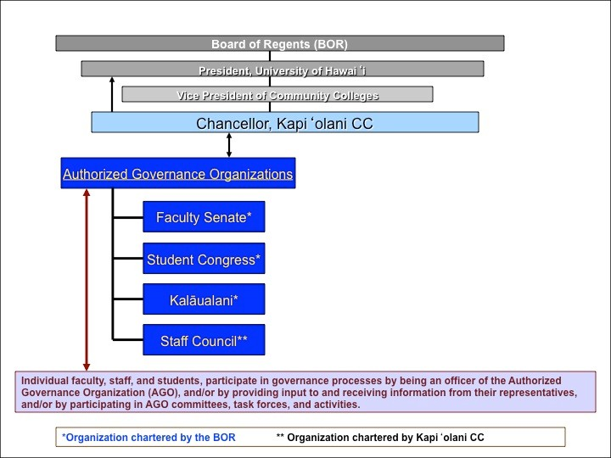

Kalāualani

The Kalāualani Council at Kapiʻ olani Community College is one of the ten branches making up the Pūkoʻa Council of the University of Hawai‘i system approved by the BOR. Each of the ten campuses has an Executive Council that represents the Kānaka Maoli from the respective campus. Kalāualani Council provides a formal, independent organization through which all Native Hawaiian and Native Hawaiian serving employees of Kapiʻolani participate in the governance of the campus as it relates to Native Hawaiian programs, activities, initiatives and issues in alignment with the Pūkoʻa Council.

On June 29, 2009, the Charter of the Pūkoʻa Council was approved by the BOR. “The purpose of the Pūkoʻa Council is to provide a formal, independent voice and organization through which the Native Hawaiian faculty, administrators, and students of the University of Hawai‘i System can participate in the development and interpretation of system-wide policy and practice as it relates to Native Hawaiian programs, activities, initiatives, and issues.” One of the functions of the council is to “provide advice and information to the President of the University on issues that have particular relevance for Native Hawaiians and for Native Hawaiian culture, language, and history.”

On May 4, 2015, the Chancellor of Kapiʻolani Community College approved the Bylaws of
Kalāualani. The Kalāualani Council serves as an advisor to the Chancellor on matters of the
same nature as delineated above in describing the purview of the Pūkoʻa Council. As stated in the bylaws,

“The Council will:

Lead the campus in the implementation and attainment of the goals and objectives of Hawaiʻi Papa o Ke Ao.

Define Kapiʻolani Community College’s kuleana to Hawaiians and the ʻāina.

Advise the Chancellor and Administrative Team regularly on the concerns of Hawaiians at Kapiʻolani Community College.

Guide Kapiʻolani Community College’s broader efforts to better serve Native Hawaiians in the areas of teaching, curriculum development, long- range planning, strategic planning, accreditation self-study, policy development, and implementation.

Identify Native Hawaiian issues that influence curriculum and instruction and provide recommendations for training in culturally appropriate curriculum development and instruction.

Advocate, evaluate, and assess fairness and equity in all decisions, resource allocations and grants related to Kapiʻolani CC as a Native Hawaiian Serving Institution.

Assist in educating administration, faculty and staff at Kapi‘olani about issues important to Native Hawaiians including self-determination, intellectual and cultural property rights, sanctity of land, proper pronunciation and usage of the Hawaiian language.”

Faculty Senate

The Faculty Senate of Kapi‘olani Community College (Kapi‘olani CC) provides a formal independent organization through which the faculty can participate in the governance and policy-making determination of the College; and promotes communication among the faculty, staff, students, administration, and the Board of Regents to enhance and advance the College and the campus community. The Senate has the responsibility of considering policies, positions, and actions that pertain to the individual or collective role of the faculty.

The Board of Regents Policy RP 1.210, Chapter 1, General Provisions, Section 1-10, entitled Regents’ Policy on Faculty Involvement in Academic Decision Making and Academic Policy Development, states that the Faculty Senate has… “the responsibility to speak for the faculty on academic policy matters such as: (1) Determining the initiation, review, and evaluation of proposed, probationary, or authorized research, instructional, and academic programs; (2) Budget planning and implementation; (3) Student-faculty relations; (4) Evaluation of faculty and campus academic administrators; (5) Establishing a canon of professional ethics and an effective means of professional maintenance of those ethics, including faculty self-discipline; and (6) Other subjects referred to it or them by the chancellor, or by request of the appropriate faculty organization.” “On these matters the power of review and concurrence or final decision lodged in the board or delegated to administration officers should be exercised adversely only in exceptional circumstances and for reasons communicated to the faculty.

Furthermore, Chapter 1, Section 1-10 states, “the role of the faculty as set forth herein shall not be delegated to any other entity by the faculty organization established pursuant to this policy”. Pursuant to BOR policies, the faculty members at Kapi‘olani CC have adopted a Faculty Senate Constitution, which enumerates the specific areas of Faculty Senate responsibility at Kapi‘olani CC. Faculty, the Chancellor, and the Board of Regents have approved this Constitution.

The Senate consists of 16 senators, elected to represent the voices and perspectives of their departments and units. The Faculty Senate meets at least monthly during the academic year and utilizes committees to assist it in the performance of its work. It maintains a public web site (facultysenate.kapiolani.hawaii.edu). This site includes official Senate documents and work products, including meeting agendas, approved minutes, the Faculty Senate Constitution, and other documents and reports.
Student Congress

The Student Congress is a University of Hawai‘i Board of Regents chartered student organization and abides by the rules, responsibilities, and obligations set forth by the Associated Students of Kapi‘olani Community College (ASKCC) Student Charter. The Board of Regents Policies, RP 7.201, Chapter 7, Student Affairs, states that, “1. The board encourages the establishment of a robust student life program, including the establishment of student organizations. 2. The board recognizes the establishment of two types of student organizations: Chartered Student Organizations and Registered Independent Organizations.”

At Kapi‘olani CC, the ASKCC Student Congress serves as the CSO representing the student body. The other two CSOs at the college are the Board of Student Activities and the Board of Student Publications. The purpose of the Student Congress, according to the ASKCC Charter, Article II, is to “develop and implement plans for programs and activities sensitive to the needs and interests of the students; and to promote active student interest and participation within the college community”. ASKCC Student Congress advises and participates, through established communication channels, in college governance in matters relating to student life, programs, and activities.

Staff Council

In order to include personnel functioning as staff at the college in the shared governance of the college, the Staff Council was established in 2000, and its Bylaws approved by former Chancellor Leon Richards. As the Bylaws state, “The Staff Council represents and is comprised of members and non-members of HGEA/UPW, units 1, 3, and 8; these include staff personnel that are full/part time employees of the college.”

The Staff Council Bylaws include a mission statement that states the Staff Council, “…will provide a formal voice and organization representing the staff in the administration of the campus, while offering avenues to enhance the professionalism, skills and competencies of our staff members, creating a working atmosphere of respect, dignity, equality and cooperation”. The Bylaws further explain that, “The paramount aim of the Staff Council is to serve as an advisory body to the Chancellor of the college on any and all matters concerning staff.”

According to the Bylaws, the responsibility of the duly selected representatives of the council “shall be dedicated to the active involvement of all Staff Council members in the undertakings of the council and shall solicit and consider recommendations, suggestions, and inquiries from its members,” thus institutionalizing a mechanism for participation in the governance of the college specifically for all staff personnel in the college community. To further staff participation, the Staff Council has established committees comprised of representatives from each unit.

A. Standing Councils (see Figure 2)

In addition to the authorized constituent-based organizations that are authorized to share in the governance of the college in specific areas of responsibility, as noted above, the college has expanded the opportunities for campus leaders, faculty, staff, and students to participate in the governance process through the use of standing councils that deal with a wide variety of long-term and/or on- going college wide issues as advisors to executive administrative personnel. Of primary importance, as it advises the Chancellor directly, is the Chancellor's Advisory Council.

Figure 2. Standing Councils, Ad Hoc Committees & Task Forces, and Campus-wide Input
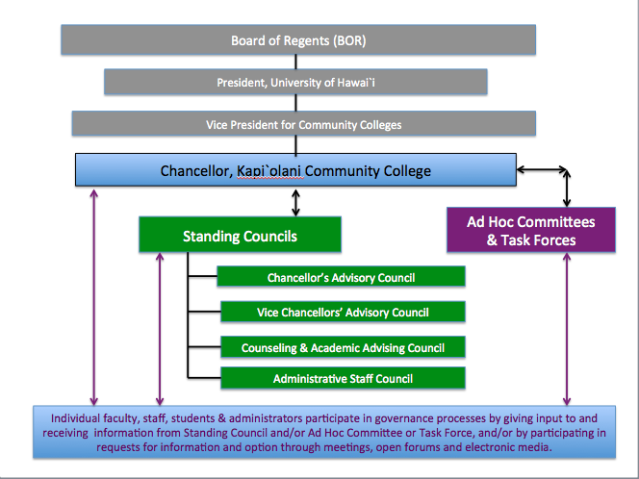

Chancellor’s Advisory Council (CAC)

The CAC was created to implement key components of the UH System-wide Executive Policy E4.201 Integrated Long Range Planning Framework. The council is composed of administrative leaders and faculty of Academic Programs and Administrative and Educational Support Units, the Counseling and Academic Advising Council, and representatives from the four authorized, constituent-based organizations.

The CAC functions as one of the Chancellor’s mechanisms for presenting and discussing issues, concerns, and ideas for the purpose of consulting with campus leaders in areas of campus life; and serves as a forum for the open exchange of ideas of individual members and formally invited guests and for discussions concerning the decisions made by the authorized organizations and/or other advisory groups. As the CAC is the only campus body to include a cross section of academic, support, authorized organizations, and management personnel, it serves as an integrative and centralized mechanism for discussion, analysis, and recommendation related to matters of planning (i.e., program review, tactical plans, strategic and long range plans), budgeting, and program assessment. The CAC is a direct avenue through which the Chancellor can gather and disseminate information and is an essential element in the administrative decision making process for the Chancellor. The CAC is utilized by the Chancellor as a forum for the exchange of ideas through direct interaction and communication of its members; i.e., the CAC affords members the opportunity to debate issues, collaborate with a variety of colleagues and co-workers, and discuss, enumerate, elucidate, analyze, and evaluate ideas and policy issues of college wide importance. In addition, CAC disseminates information and discusses issues with members of the groups, programs, and units it represents, in order to better inform the CAC and college decision-making.

The CAC has the responsibility for review and recommendation to the Chancellor concerning:
(a) planning, assessment, and program review; (b) the college mission statement; (c) the college strategic plan and periodic assessment of progress toward the goals of that plan; (d) the college long-range development plan, and periodic assessment of progress toward the goals of the plan; (e) constructing the college budget and setting priorities; (f) the tactical plans and periodic assessment of progress toward the goals of the plans; and (f) the review of the results of program reviews for Academic Programs and Administrative and Educational Support Units. Minutes of the Council’s meetings are posted weekly on Ohana, the College’s intranet system.

Administrative Staff Council

The Administrative Staff Council meets on a weekly basis and advises the Chancellor. This group includes the Vice Chancellors for Academic Affairs, Student Affairs, Administrative Services, the three Academic Program Deans, Dean for the Office of Community Relations and Continuing Education, the Chancellor, and the Chancellor’s Executive Assistant. In addition, when appropriate, guests are invited to inform the council on specific topics. Any and all issues concerning the college are discussed at the Administrative Staff Council, and members are responsible for the two-way flow of information so that the college community is informed of administrative decisions, and so that these decisions are informed by the needs, ideas, and visions of the college community members. Minutes of the Council’s meetings are posted weekly on Ohana, the College’s intranet system.

Vice Chancellors’ Advisory Council (VCAC)

The VCAC makes recommendations to the Vice Chancellors for Academic Affairs, Student Affairs, Administrative Services, and the Dean for Community and Continuing Education. The VCAC serves as a forum for discussions on the impact of policy, and for problem-solving for operational matters in the areas of instructional activities, student services, workforce development and continuing education. This council consists of the Vice Chancellor for Academic Affairs, the Vice Chancellor for Student Affairs, the Vice Chancellor for Administrative Services, the Dean for Community and Continuing Education, the academic program deans, department chairs, academic support unit heads, and the college curriculum specialist.

Counseling and Academic Advising Council (CAAC)

The CAAC makes recommendations to the Vice Chancellor for Student Affairs, as well as the Vice Chancellor for Academic Affairs, and has representation on the CAC. The purpose of the CAAC, according to its General Guidelines, is to “improve the counseling and academic advising process for current and potential students at Kapi‘olani Community College.” The CAAC is responsible for discussion, analysis and recommendations on issues related to: (a) academic advising; (b) counseling, such as student engagement, development, and success; and(c) college wide counseling and academic advising, and professional standards and practice. Counselors and related student services personnel can be members of the CAAC.

B. Ad Hoc Committees and Task Forces (see Figure 2)

From time to time, special areas of need arise that call for the concentrated effort of a group of individuals to advise the College on the best course of action. In such times, the College creates ad hoc committees and task forces and utilizes appropriate members of the College community. These project-specific committees and task forces offer direct opportunities for faculty, staff, and students to participate in the College’s governance process, e.g., in such areas as strategic planning, long-range development planning, and budgeting. These opportunities are in addition to the standing committees and task forces created within each of the four authorized organizations, which also offer avenues for participation in the governance of the College to all members specific to these groups.

C. Campus-wide Input (see Figure 2)

The mechanisms for participation outlined above afford myriad opportunities for members of the College community to advise the College Administration at a variety of levels. Administrators may receive solicited or unsolicited advice from the four authorized organizations and/or the standing councils, as well as receive the results or findings of ad hoc committees or task forces on specific issues. In addition, the Administration at times solicits input from all members of the campus for the purpose of directly involving as many faculty, staff, and/or students as possible in the information gathering, processing, and decision-making related to issues with campus wide importance, e.g., the long range development plan and the college’s strategic plan. This campus wide process is the most inclusive opportunity for participation in the College’s governance and affords decision makers the opportunity to utilize the broadest range of knowledge and expertise in the college community through the use of presentations, meetings, open forums, and electronic communication technology before decisions are made.

Summary

The purpose of this document is to describe the various means available to all personnel at Kapi‘olani Community College to participate in the governance of the college (see Figure 3: Governance at Kapi‘olani Community College). The BOR has established a system of shared governance that authorizes the forming of authorized constituent-based organizations and charges these organizations with the responsibility for making recommendations or providing advice on the specific areas of responsibility. Furthermore, Kapi‘olani CC provides additional avenues for participation in the College’s governance through: standing councils that college executive administrators consult on a variety of issues; ad hoc committees and task forces that are created for specific purposes; and the opportunity for direct participation, with issues of campus wide importance, for all college personnel through a variety of face-to-face and electronic media formats.

Figure 3. Governance at Kapi‘olani Community College
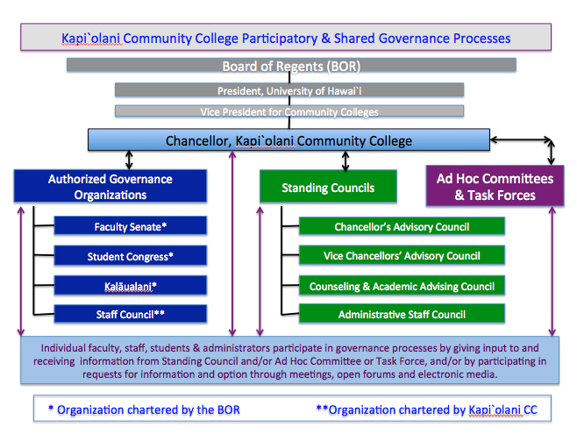

Reference:

University of Hawai‘i Reference Guide, June 2014, prepared by the Office of the Executive Vice President for Academic Affairs.

